HISTORIC PRESERVATION INDUSTRIAL
RECONNAISSANCE SURVEY
CITY OF NIAGARA FALLS
NIAGARA COUNTRY, NEW YORK

NOVEMBER 2007

Prepared under contract to:

City of Niagara Falls
Department of Community Development
Office of Planning & Environmental Services
PO Box 69
Niagara Falls, New York 14302-0069

In conjunction with:

Niagara Falls Historic Preservation Commission
Niagara Falls City Hall
745 Main Street
Niagara Falls, New York 14302

And

New York State Office of Parks, Recreation
And Historic Preservation
Historic Preservation Field Services Bureau
Peebles Island, PO Box 189
Waterford, NY 12188-0189

Prepared by:

Francis R. Kowsky (62 Niagara Falls Blvd., Buffalo, NY 14214)
Martin Wachadlo (368 West Ave., Buffalo, NY 14201)

TABLE OF CONTENTS
______________________________________________________

Description of the Project …………………………………………………………….2

Niagara Falls as a Source of Power for Manufacturing:
A Historical Overview …………..………………………………………………….4

Survey of Remaining Historical Industrial Sites …………………………………….….35

Bibliography ………………………………………………………………………49

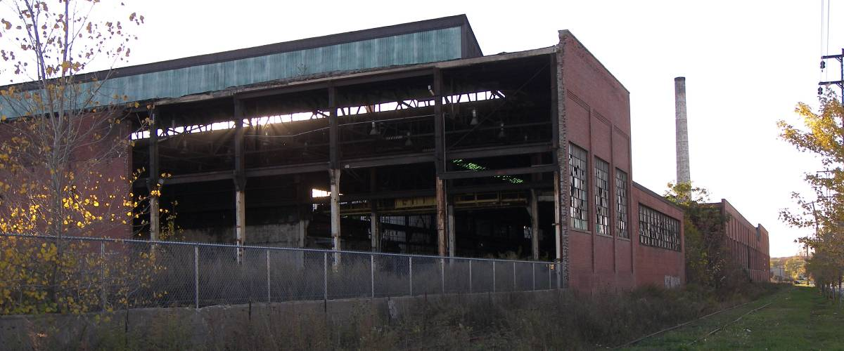
Former National Carbon Company factory complex along College Avenue

DESCRIPTION OF THE PROJECT

The project lays out a narrative history of industrial development in Niagara Falls, New York, beginning in the early nineteenth century through the twentieth century. This history traces early industries, especially those that established themselves after the arrival of the railroad in the 1840s. The history also includes the development of water powered industries along the Niagara River and on Green Island and the reversal of the mainland and island industrial landscape with the creation of the Niagara Reservation (the present Niagara Falls State Park) in 1885. Primarily, the study concerns itself with the advancement of electro-process industries that came into being in the 1890s in the city after the creation of the two hydro-electric power companies, the Niagara Falls Hydraulic Power and Manufacturing Company (the Schoellkopf Power Station) and the Niagara Falls Power Company (the Adams Power Station). The narrative concludes with the decline of industry in the city in the latter part of the previous century. The narrative and inventory survey includes tunnels, canals, offices, and manufacturing plants. Commercial, residential, institutional, and religious architecture was excluded.

Documentary research has been undertaken at a number of places. Chief among these is the Niagara Room, the local history collection, of the Niagara Falls Public Library. Other sites include the Buffalo and Erie County Public Library; the Buffalo and Erie County Historical Society; and the Butler Library, at Buffalo State College. As the bibliography indicates, the authors consulted primary and secondary sources, historic maps, municipal records, unpublished materials, historic photographs, and the online files of the NYSOPRHP and the National Register of Historic Places. The authors wish to thank Maureen Fennie and Linda Reinumagi at the local history collection of the Niagara Falls Public Library, and Thomas Yots, Niagara Falls City Historian and chair of the Niagara Falls Historic Preservation Commission, for their valuable assistance. Derek Waltho, of the Niagara Falls Office of Planning & Environmental Services, was also most helpful with providing maps and other documents relevant to the project.

The criteria and guidelines used in the inventory section to determine the probability that an existing structure would possess historic significance were those of the National Register of Historic Places Criteria for Evaluation. These are as follows:

The quality of significance in American history, architecture, archaeology, engineering, and culture is present in districts, sites, buildings, structures, and objects that possess integrity of location, design, setting, materials, workmanship, feeling, and association and

- that are associated with events that have made a significant contribution to the broad patterns of our history; or
- that are associated with the lives of persons significant in our past; or
- that embody the distinctive characteristics of a type, period or method of construction or that represent a significant distinguishable entity whose components may lack individual distinction; or
- That have yielded, or may be likely to yield, information important in prehistory or history.

This project was a collaborative effort of the two professional architectural historians. Francis Kowsky, however, was largely responsible for the overview statement that outlines the rise and fall of city’s internationally notable industrial heritage. Martin Wachadlo took the greatest responsibility for the extensive field research that produced the inventory section. Martin Wachadlo was also responsible for the contemporary photographs of buildings and sites.

The authors had the pleasure of working on this out of the ordinary assignment from June to November 2007.

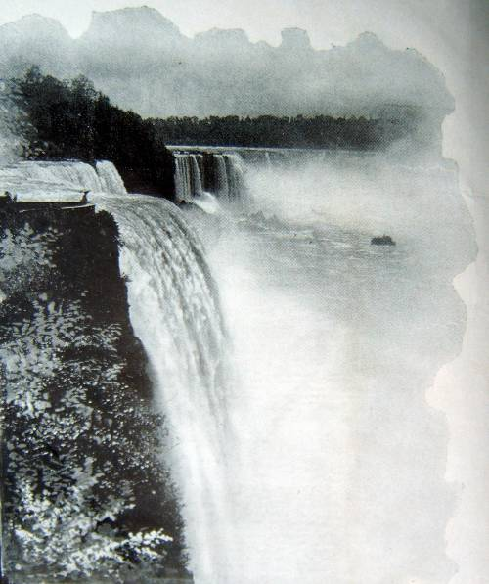

“ . . . the Niagara River and Niagara Falls thundered along, at first an obstacle to man’s progress and a challenge to his initiative to turn the torrent to a useful purpose.”

NIAGARA FALLS AS A SOURCE OF POWER FOR MANUFACTURING:
A HISTORICAL OVERVIEW

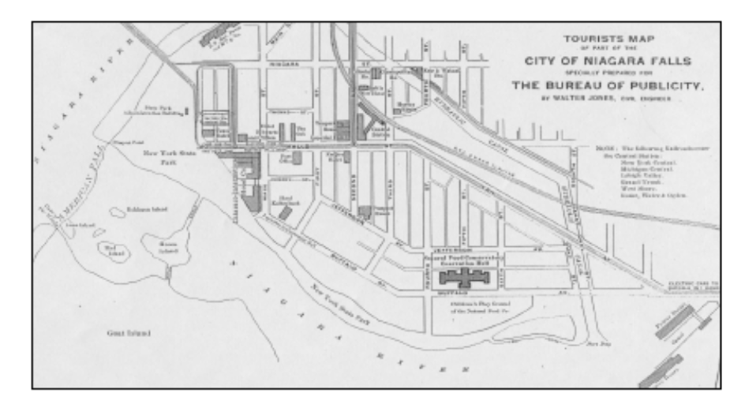



Map of Niagara Falls, New York
c. 1903

§ The City of Niagara Falls

The present-day City of Niagara Falls, which began its history in 1805 under the go-getting name of Manchester, came into being at the dawn of the local industrial age. When incorporated in 1892, the new city was formed by combining the villages of Niagara Falls (incorporated in 1848), which included a settlement begun in 1823 between the river and present day Twentieth Street and known as Clarksville, and Suspension Bridge (as well as a small portion of the Town of Niagara). At the time, Niagara Falls was home to a number of small industries that utilized the abundant water power form the river. It was, however, more well known as a tourist destination. Suspension Bridge, located down river from Niagara Falls, was the site of an international railroad bridge constructed in 1855 (it replaced a carriage suspension bridge erected a few years earlier) linking the American side of the gorge with Clifton, Ontario. By the early 1890s, Suspension Bridge had grown into a busy rail center serving the brisk American-Canadian trade economy. The marriage of the two villages was a natural outgrowth of their development during the earlier decades of the nineteenth century. “Common trade interests had brought the people of the two places into close business and social relations,” writes an earlier chronicler of the area, “so it was comparatively an easy matter to adjust affairs on consolidation.” Looking back from the perspective of only twenty years, the same writer reflected:

In 1892 the City of Niagara Falls was a far different place than it is now. The population of 11,000 was pretty much all on the river side of Tenth Street. In the middle distance, between the two villages . . . there were few houses. The old horse cars were just giving way to trolleys . . .

Between 1892 and 1915, the population of the city leaped from 11,000 to almost 40,000. A new era had dawned at the “new Niagara.”

§ Early Types of Industries Using Water Power

The history of harnessing the flow of the Niagara River at Niagara Falls for manufacturing can be said to have begun when the area was part of New France. In the 1750s, Daniel Joncaire, the French portage master at the Falls, took upon himself to divert river water above the Upper Rapids into a short millrace to turn the wheel of a sawmill. Successive British and early American residents sporadically added to Joncaire’s undertaking.

By the late nineteenth century, an undistinguished assortment of mills had grown up along the mainland, as the American bank of the river was known, and on Bath Island (the present Green Island) in the American Rapids. A shallow canal that had been built parallel to the river from the Upper Rapids to Prospect Point was home to a number of middling enterprises, including a laundry, a furniture factory, paper mill, planning mills, a foundry, and a hotel. All of these buildings received power from shafts or rope-drives propelled by wheels turned by the age-old, tried and true (but relatively inefficient) arrangement whereby water was directed either above the wheel (overshot) or below it (undershot). All evidence of this earlier commercial district—“an indescribable assortment of miscellaneous rookeries, fences and patent medicine signs,” Frederick law Olmsted called it--passed out of existence with the establishment of the Niagara Reservation in 1885 and the subsequent efforts to return the mainland to something like its pre-settlement, natural appearance. Nonetheless, the advent of this ancient form of power involving the diversion of flowing water into races to turn mill wheels and other devices initiated the transformation of the area around the Falls from untouched wilderness to one of the planet’s most extensive industrial addresses.

In 1853, a more ambitious attempt had been made to utilize the river’s power with the construction of a twenty-two-foot-wide canal. The 4500-foot long Hydraulic Canal, as the enterprise was called, began about one mile above the Falls and crossed the city diagonally to a point about one thousand feet beyond the American Falls. This area on top of the gorge immediately north of the American Falls came to be called the High Bank. The actions of the canal company here began the disfigurement of the cliff wall.
(This area would remain outside of the Niagara Reservation when it was created in the 1880s.) The company sought to use the canal to generate water power by creating a large holding basin at the edge of the High Bank. Water from the basin would then turn large water wheels as it descended into the gorge below. To achieve its aim, the company obtained the right to excavate down the side of the cliff for 100 feet. “That was thought to be sufficient then," relates a somewhat later description, “because it was not supposed that wheels could be built to stand a pressure at a higher head. Mills in those days did not attempt to use more than fifty to sixty feet head.” Once complete

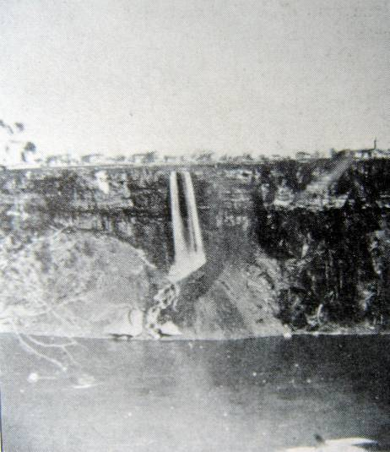

The High Bank in 1860
to a depth of ten feet in 1857, the canal became home to the city’s first flour mill. (In the late nineteenth century, Niagara County was a major wheat growing region.) However, prosperity eluded Augustus Porter, the primary local entrepreneur who had promoted the canal, and the other canal owners. In 1877, the ill-fated Hydraulic Canal (which the city filled up with earth between 1958 and 1973) went up for auction. Buffalo businessman Joseph Schoellkopf purchased it. Schoellkopf took over the Niagara Falls Hydraulic Power and Manufacturing Company and began vigorously promoting the canal as a site for water-powered industry.

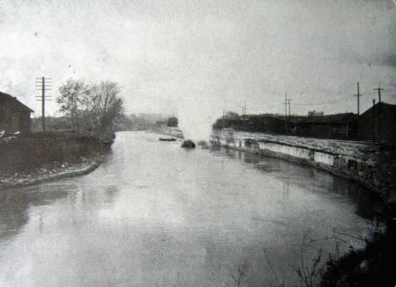

The Hydraulic Canal

Obtaining the right to use the river’s edge below the High Bank, Schoellkopf made improvements to the water power potential of the canal and was able to attract new businesses. “Power connection was furnished the factories,” explained a reporter,

by means of shafts sunk in the rock some distance back from the edge of the bank. Wheels were placed in the shaft, and canal water was admitted to turn them. In most cases, a tunnel had to be driven from the bottom of the shaft to the face of the bank for the discharge of the water after passing the wheels. In other cases, wheels were lodged in notches in the face of the cliff. In 1881, the company installed a power plant from which to deliver power to customers at their mills. A shaft 20 feet by 40 feet was sunk in the rock 80 feet deep about 2300 feet back from the river bank. From the bottom of the shaft a tunnel was driven to the face of the bank for a tail race. Power developed from the wheels in use in this plan was transmitted by shaft, belting or rope to customers within 300 feet of the wheel pit.

This system was surely the ultimate example of the use of water power to drive the wheels of industry. It was soon to give evolve into much more powerful form of energy production.

§ The Development of Hydro-Electric Power

In 1881, the Brush Electric Light Company, one of Jacob Schoellkopf’s tenants on the Hydraulic Canal, built an electric generator that operated by mechanical power supplied by the canal water. Current from this generator, which was one of the first of its kind in the world, illuminated several arc lamps in the village of Niagara Falls. Recognizing the historic significance of this accomplishment, the village elders honored the occasion with a public parade. Railroad companies even brought visitors from other parts of the country to marvel at the brilliant lights.

In 1882, Schoellkopf, realizing the potential of electricity, erected a small power house at the end of the Hydraulic Canal. Here water power was converted into electricity employing the technology of the dynamo or generator. Invented in England in the 1830s, the dynamo allowed for the production of electricity by mechanical rather than chemical means. Dynamos, which to historian Henry Adams came to represent the spirit of the modern age, were commercially available by the 1870s. (A motor, by contrast, is a mechanical devise that converts electrical energy to mechanical energy to perform various types of work.)
Schoellkopf proved to be a prescient businessperson who could see where the path to the future at Niagara Falls lay. With the feasibility of electrical power generation a nascent reality and formation of the rival Niagara Falls Power Company in the wind, Schoellkopf quickly undertook to transform his Hydraulic Canal to the production of electricity. As explained by a contemporary observer, Schoellkopf proceed to

enlarge the canal from 30 feet wide and 6 feet deep to 100 feet wide and 14 feet deep and to construct a power house at the foot of the river slope. Canal water is carried to the power house by means of flange steel penstocks. It has a fall of 210 feet to the wheels [generators] and is discharged by tail races. . . . Electrical installation occurred in 1896, since which time the company’s operations have steadily grown.
The outlay for this equipment has cost at least $6,000,000.
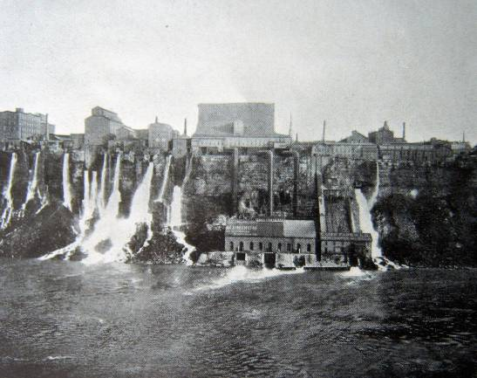

The Hydraulic Power and Manufacturing Company’s generating plant below High Bank. The area became part of Niagara Falls State Park in the 1960s.

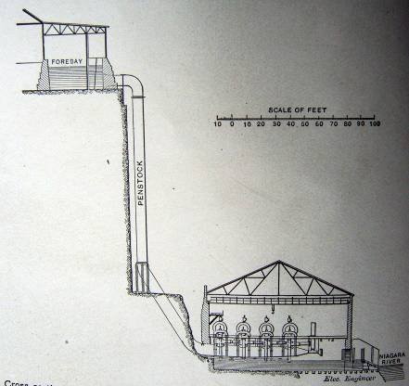

Cross Section of the HPMC plant. Originally, the plant produced only direct current. Beginning in the 1890s—probably in response to the Niagara Falls Power Company’s opening—the gorge facility turned out alternating current as well.

In 1896, Schoellkopf’s Hydraulic Power and Manufacturing Company’s four riverside turbines were supplying 35,000 horse power of energy to several mills at High Bank. Direct current was conducted to the top of the High Bank by means of wires and aluminum bars that ran along side the penstock (a conduit for conducting water) and then underground to various customers.

In 1904, Schoellkopf’s successors completed the widening and deepening of the canal and added a second plant building at the base of the High Bank. Water entering the Hydraulic Canal from the river at Port Day, as the mouth of the cross-town canal was called, also reached the turbines in the enlarged facility by means of three large penstocks that descended from High Bank down to the power station at the river’s edge some two hundred feet below. The new output was 100,000 horse power. By the 1920s, with further improvements it was one of the largest hydro-electric power plants in the world. Together with the Adams Station, as the original Niagara Falls Power Company’s plant came to be known after the merger, it provided power to over 1500 factories locally, as well as residential and commercial costumers.

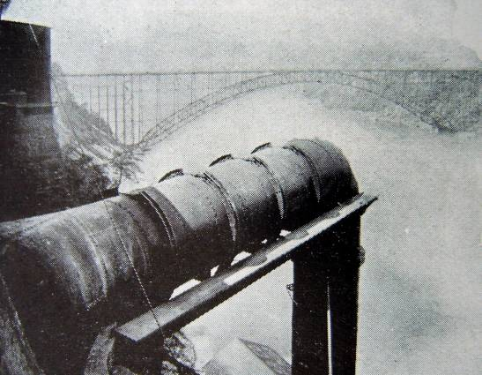

Penstock for delivering river water to the Schoellkopf Station

The Brush Company’s experiment and Schoellkopf’s success inspired a much bolder scheme to use Niagara River water to power electrical generators. In 1883, Thomas Evershed, an engineer with the Erie Canal, proposed digging a huge tunnel beneath the town of Niagara Falls to turn water wheels at the upstream point to operate electrical generators. Electricity would be generated at a site above the Falls rather than below them, the great tunnel being needed to drain the water delivered to the underground turbines by the descending penstocks out to the river While Evershed and a host of international engineering advisors, including Theodore Turrettini of Switzerland and Clemens Hershchel of Germany, were working out technical problems, Edward Dean Adams, president of the Cataract Construction Company, and William B. Rankine, an up-and-coming Niagara Falls attorney, assembled financing from American and European investors for this astounding project. From their efforts, the Niagara Falls Power Company came into existence in 1889. An early chronicler of electrical power generation described the Herculean process of construction:

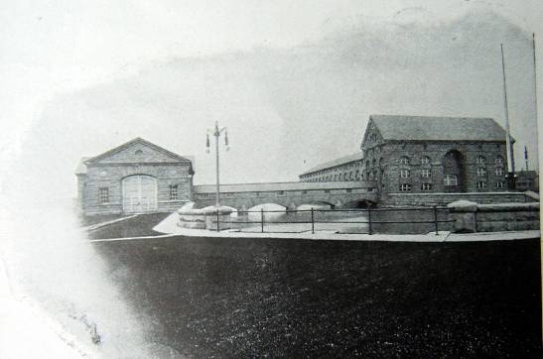

Niagara Falls Power Company, Power House No. (L); Transformer House (R)

[The company] dug a canal 250 feet wide and 12 feet deep from the river about one and a half miles above the Falls and extended it inward 1700 feet to the power house. At this site a wheel pit 158 feet deep and 400 feet long was dug in solid rock. Water reaches the pit by means steel penstocks 7.5 feet in diameter and it whirls turbines placed there 250 revolutions per minute. The turbines are connected by shaft with the ten 5000 horse power dynamos at the surface. To provide a tall race for the water it was necessary to build a tunnel 7000 feet long under the town to the river. The tunnel is large enough to carry water from twenty turbines . . .

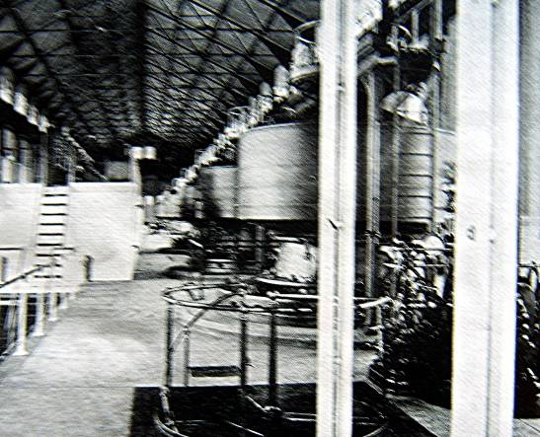

Interior of NFPC Adams Power House.

The following year, under Evershed’s direction, an army of workers began construction on the 7500-foot-long, brick-lined passageway. In 1895, the first two buildings of the power plant went up to the designs of McKim, Mead and White, one of the leading national architectural firms. The plant used Westinghouse generators to produce alternating current, which would allow electricity to be transmitted beyond Niagara Falls.
The Romanesque style stone structures of the Adams power plant housed the enormously powerful energy producing machinery that turned out electricity in quantities never seen before. Turbine-driven, alternate current dynamos, recalled an early historian of Niagara Falls’ electric generation, operated “under a head more than twice as great as had ever been built with generators, five times as large as had ever been attempted with transformers.” In the late summer of 1895, the Niagara Falls Power Company delivered electricity for the first time to local customers. In November 1896, electricity was sent over lines to Buffalo, some 20 miles away in what observers hailed as the first long distance transmission of electrical power in the world. It was here at Niagara Falls that
for the first time in the United States electric power was available in large quantity and at a low rate. “The hydroelectric development of Niagara Falls in the 1890s,” stated the geographer Patrick McGreevy, “seemed to many as a sort of capstone on humanity’s victory over nature.”

Hydroelectric power was cheapest, however, when consumed close to its source of production. “Here companies can offer power here at very attractive prices,” observed a contemporary newspaper reporter. However, when transmission is involved, he noted,

prices must advance because of waste, which amounts to 20 per cent between here [Niagara Falls] and Buffalo. The charge here is $20 per horsepower. At Buffalo it is $25. If the proportion of waste were continued to Rochester, seventy-five miles away, it would be 60 per cent, and the price at Rochester would be nearly $35 per horse power. That price might not be unattractive except as compared with $20, but manifestly, consumers at much greater distances would be repelled. They could get power at home as cheaply as from here, and perhaps more satisfactorily.

For that reason, the steady stream of electricity that the Niagara Falls Power Company had to sell soon attracted new and larger industries to Niagara Falls. Fully aware of the potential, the power company acquired a large amount of land upriver and inland from the plant. The company planned to lease this land to its
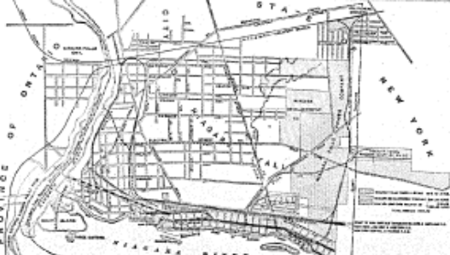
future customers and even engaged the services of Olmsted Brothers, the leading landscape architecture firm in the United States, to map and perhaps make suggestions for arranging the site, which was served by the Niagara Junction Railway Company. Thus, the company envisioned becoming landlord as well as energy supplier to the area’s new electro-process industries. Their investment soon proved profitable. “Actual plant investment, exclusive of the power companies,” reported a writer in 1900, has grown from $500,000 to $1,500,000 in the three years that electrical power has been sold . . . and plans for extensions, improvements, and fresh investment are freely discussed.”

§ The Three Industrial Areas of the City

Historically, the industries of Niagara Falls were located in one of three areas: the High Bank, along the gorge rim somewhat down river from the Falls; the Buffalo Avenue industrial area in the eastern section of the city; and the Highland Avenue area in the north part of town. These three zones shaped the development of the industrial local landscape, a fact that was clearly evident to early twentieth-century residents. “The manufacturing districts of Niagara Falls have become well defined,” declared the local newspaper in 1912.

One includes the property of the Niagara Falls Power Company lying along the upper river; one is below the Falls on the property of the Hydraulic Power Company, which is known as the lower milling district, and one in the north section of the city, which is known as the new industrial section.

“This new industrial section [Highland Avenue area] was necessitated by the overcrowding of the others which, at the time of their establishment, were considered adequate for the city’s needs for many years to come. All of these plants acquired in recent years have been located in either one or the other of these districts. This is an advantage in that it keeps the manufacturing districts intact, facilitates the service of the various corporations by the power companies, and protects residential sections from undesirable encroachments.

§The Advent of Electro-process Industries

The first three companies to locate at Niagara Falls in 1895 to take advantage of the Adams station electricity were the Pittsburgh Reduction Company (later the Aluminum Company of America), which soon opened another plant at the High Bank, the Carborundum Company (the first to produce synthetic abrasive, known as carborundum or silicon carbide), and the Acetylene Light, Heat and Power Company (later Union Carbide). Truly, a

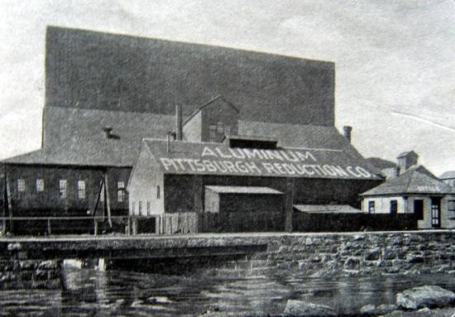

Pittsburgh Reduction Company’s High Bank plant. Known as the Lower Plant (it was further down river from the company’s other plant on lands of the Niagara Falls Power Plant), this facility on the edge of the gorge opened in November 1896. Smaller than the Upper Plant, it used direct current supplied by the Niagara Falls Hydraulic Power and manufacturing Company from its plant (later known as the Schoellkopf Station) directly below the plant at the foot of the gorge cliff.

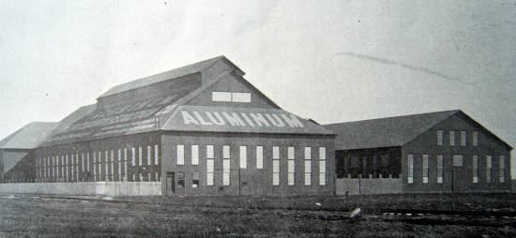
Pittsburgh Reduction Company at the Niagara Falls Power Company. Land for the plant, which was known as the Upper Plant, was acquired from the Niagara Falls Power Company about one-quarter mile upriver from the Adams generating plant. It began operation in August 1895.

new era in American manufacturing was about to begin in which electricity would play for the first time in human history a central role. Indeed, the electro-process industries, as these new businesses came to be called, were as much in their infancy as was hydro-electric power generation. Exuberant optimism ruled the day in the Cataract City. “Some experts and enthusiasts in progression,” observed a contemporary, “have figured out that at the recent rate of increase Niagara in a few years will have a population of 1,000,000 and will build to the Buffalo line.”

Growing industrialization would steadily increase the number of people living here as the dream of an industrial metropolis envisioned by the first settlers of Manchester now appeared to be becoming a reality. Indeed, the “new Niagara” captured both the attention of industrialists and utopian thinkers. Nicola Tesla himself, promoted the notion that Niagara’s power was virtually unlimited and would one day power the street lights of Paris and the trolleys of London. Others assumed Tesla’s unbounded optimism concerning the city’s future. In 1894, King Camp Gillette, inventor of the safety razor, published his book The Human Drift in which he declared that “here is a power that if brought under control, is capable of keeping in continuous operation every manufacturing industry for centuries to come, and, in addition, supply all the lighting facilities, run all the elevators, and furnish the power necessary for the transportation system of the great central city.” Gillette envisioned a vast city of sixty million inhabitants at Niagara Falls that he called simply Metropolis. “Let us start the ball rolling with such a boom and enthusiasm that it will draw the wealth and sinew of the nation into its vortex—the great future city of ‘Metropolis’ . . . and let a new era of civilization and progress shed its light of hope on the future of mankind,” he proclaimed. Another inventor, Leonard Henkle, also proposed a utopian scheme that would see a new skyscraper city built directly over the Falls, which would perpetually furnish power to the overhead mega structure. The city’s distinctiveness as a place of human progress through industry continued to inspire civic pride until the Great Depression. From 1925 to 1930, the city staged an annual “Festival of Lights” honoring local industry and technology, all presided over by a “Queen Electra.” Unfortunately, in the late twenty century the dream proved to be an illusion as steady decline set in.

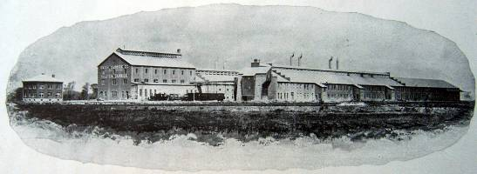
Union Carbide Company. (Located on NFPC land in the Buffalo Avenue area) “The plant of the Union Carbide Company is one of the largest on the lands of the Niagara Falls Power Company. It is located about one and one-half miles east of the power stations, the site occupying about eight acres. The buildings are of brick and steel, covering a space over 200 feet wide and more than 880 feet long. . . . The Niagara Falls plant of Union Carbide Company is known as Plant No. 1, and was erected in 1899. Plant No. 2 is located at Sault Ste. Marie, Michigan. . . . Calcium carbide and the great industry that has developed through its manufacture owe their existence to an accidental discovery made in 1892 at an aluminum works in Spray, N.C. At that time an effort was being made to reduce lime by carbon in order to make calcium, which it was hoped would prove an aid in the reduction of aluminum. While these experiments were in progress, it was discovered that the carbide product gave off an inflammable gas when it came in contact with water. An analysis resulted in its recognition as calcium carbide, an article of great commercial value. Later its manufacture was begun on a commercial scale, and today the Union Carbide Company, which controls calcium carbide manufacture in the United States, has warehouses in forty cities and its main offices in New York City and Chicago.
“Calcium carbide furnishes upwards of five cubic feet of acetylene gas per pound. This gas burns with a soft, steady, brilliant flame, and its use is now very extensive. It has won favor for town lighting and is utilized in illuminating large buildings, houses, and grounds. Its use in portable lamps is extensive.”

At the turn of the twentieth century, demand for steady, reliable electrical power grew progressively. In 1899, the Niagara Falls Power Company, which had been capitalized at $3,000,000, originally erected a second power house that doubled its capacity. The following year the Cataract Construction Company, which had acted as contractor for the power company, was dissolved and its directors elected to the power company board. (In the new century, the company turned its attention to the Ontario side of the river where it acquired controlling interest in the Canadian Niagara Power Company.) At the dawn of the new century, the Pan-American Exposition in Buffalo introduced the world at large to the great leap forward that had begun in the few years earlier at Niagara Falls. This new industrial revolution brought great prosperity to the city of Niagara Falls,
which grew from a population of 5500 in 1899 to over 90,000 by the middle of the twentieth century.

During World War I, the Hydraulic Power Company merged with the Niagara Falls Power Company (the new expanded company operated under the latter name). When expanded and refitted in 1924, the Schoellkopf Station, as the plant near the base of the American Falls came to be called, greatly increased the amount of electricity available to industry in the city of Niagara Falls. Feed water through a tunnel beneath the city, it housed nineteen turbines of different sizes with a total output of 452,000 horsepower.

The Adams power plant was mothballed, to be held in reserve for emergencies. Maintained but unused, it resumed service in 1941 to supply additional energy to wartime industries. The Schoellkopf Station ceased operation in 1956 when a large section of the High Bank fell into the gorge and crushed the historic power house. The historic Adams Power Station fell to the wrecker’s ball (the Transformer House was spared) in 1964 when the present New York Power Authority hydroelectric plant was opened.

§ The New Era of Electrochemistry

The sudden availability of abundant, cheap electricity, the accessibility of raw materials, a first-class transportation network, the continues supply of river water required for many industrial processes, and relative closeness to most of the population in the United States would combine to make Niagara Falls a major industrial center in the twentieth century. Indeed, Niagara Falls was touted as the largest electrochemical and electrothermic industrial center in the world when it was at is peak in the 1950s. At Niagara Falls, American industrial processes were transformed and new ones invented that had far reaching effects on both the production of primary materials, such as graphite, aluminum, and chlorine, and the manufacturing of goods that used these primary products. The electrochemical industry had been created virtually our of nothing,” remarks geographer Patrick McGreevy,: “Nonexistent before 1900, this industry produced insecticides, medicines, and hundreds of other products merely by shooting electrical currents through brine and other solutions.”

Industries that began to locate at Niagara Falls in the 1890s employed generally one of two types of processes: electrothermic or electrolytic. Both of these were made commercially viable by the abundance of reliable electrical energy. Indeed, the Age of Electrochemistry could be said to have begun in Niagara Falls at the end of the nineteenth century. And since it was cheaper for users of various primary commodities produced in Niagara Falls plants to be near the source of production and because within a radius of five hundred miles there were millions of consumers, many manufactures of various goods, such as silver ware, machinery, metal alloys, textiles, paper, flour and wheat products, found the city an advantageous place to set up shop.

§ Electrothermic Manufacturing

Electrothermic processes involved the operation of electric furnaces that could produce temperatures greater than ever before obtained with ordinary fuel or an oxy-hydrogen flame. Excessively high temperatures, in excess of 7000 degrees Fahrenheit, induced chemical changes in materials. The first major industry to utilize electrothermal processes at Niagara Falls was the Carborundum Company. Carborundum or silicon carbide is a synthetic abrasive. It was the first important product produced in quantity because of electrothermal processes at Niagara Falls.

In 1891, Edward G. Acheson, a former assistant to Thomas Edison, working in his laboratory in Pittsburgh filled a discarded plumber’s pot with clay and powdered coke and subjected it to high heat using electricity. When the primitive crucible had cooled, Acheson observed “a few bright specks on the end of an arc carbon. I placed one on the end of a lead pencil and drew it across a pane of glass. It scratched the glass like a diamond.” This “scratch that was heard around the world” led to the formation

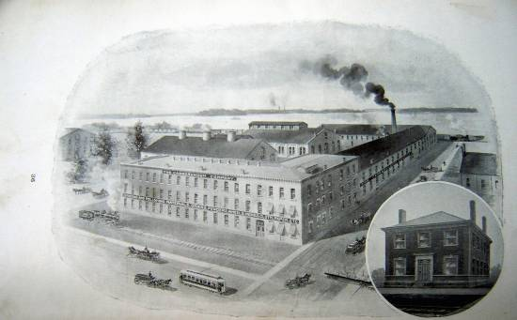

The Carborundum Company. (Located on NFPC land in the Buffalo Avenue area) “The Carborundum Company is now using three units of 1000 h.p. and one unit of 2000 h.p., which are used continuously twenty-four hours per day and 365 days per year.
“The company’s plant covers eight acres of ground and consists of a series of brick buildings having a total floor space of 221,009 square feet, and being especially adapted to the various purposes of crushing and mixing raw materials, operating furnaces, grinding and washing and sifting the carborundum, and of making the carborundum into the various marketable forms of wheels, stones, paper, cloth, etc.”

later that year of the Carborundum Company. Acheson had thought that he had fused of carbon with corundum, a natural abrasive, hence the name he gave his invention “carborundum.” In reality, he had produced silicon carbide. He soon realized his error, but decided to keep the name nonetheless. With financial backing from Andrew Mellon, Acheson established his business at Niagara Falls in 1896 when he signed a contract with the Niagara Power Company for 1000 horsepower, a huge amount of energy for the time. (after the Pittsburgh Reduction Company, Carborundum was the second major industry to sign on as a customer of the Niagara Falls Power Company electricity.)

“The new product is made,” learned the nonprofessional readers of Popular Science Monthly, “by chemically combining in the intense heat of an electric furnace of the resistance type common sand and ground coke. After the charge has remained in the furnace for about thirty-six hours in a temperature of over 7000 degrees Fahrenheit, the resulting combination is found in a beautiful crystalline form. Carborundum ranks next to the diamond in hardness and is therefore used as an abrasive.”
Acheson had discovered and developed the new field of synthetic abrasives. These could be bonded to paper or cloth, or made into grinding wheels, and sharpening tools. “Man-made abrasives and grinding machines developed for them,” observed William Wendel, a later president of the company, “made it possible to take a boy off the farm and train him in a matter of weeks so that he could turn out crankshafts and pistons and a thousand other parts which were more precise and uniform than those made by the craftsmen.” The effect of Acheson’s discovery and its enlargement on an industrial scale at Niagara Falls, indeed, had far reaching consequences. “Mass production as we know it could not have taken place without man-made
abrasives,” asserted Wendel.

Building on Acheson’s work, Frank Tone, the president of the company from 1919 to 1943, developed further uses for silicon carbide based on its ability to withstand high temperatures and abrasion. Capitalizing on the material’s refractory properties, Tone led the company to develop over 100,000 individual products.

Other electrothermic industries also located at Niagara Falls in the year just after electrical generation began. Eventually four plants were responsible for much of the world’s production of abrasives. (Plants on the Canadian side of the border augmented American
production facilities.) Silicon carbide or aluminum oxide from Niagara Falls plants was essential to the processes of grinding and polishing metals and in the creation of ever more reliable precision tools. The General Abrasives Company was one of those that augmented Carborundum’s output of synthetic abrasives. The Electro Metallurgical Company (later absorbed into the Union Carbide and Carbon Corporation) produced calcium carbide from which acetylene gas was also derived.

Thanks also to Edward Acheson, it also became possible to make synthetic graphite. Prior to his discovery, graphite was only available from mines, chiefly in

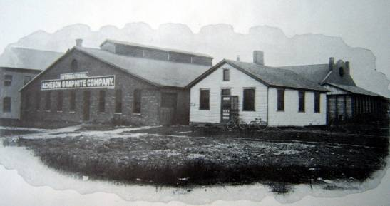

Acheson Graphite Company. “In the plant of the International Acheson Graphite Company is found one of the few successful duplications of nature’s processes. Graphite and its many important uses have been known for ages, but it is only during the last few years that it has been produced artificially. The company started in the year 1898 and contracted for 500 h.p. with the Niagara Falls Power Company. . . . In 1891 . . . while manufacturing [carborundum] in an electric furnace, Mr. Acheson frequently found in the latter a form of carbon having all the properties of graphite, and investigation proved that this was formed by the decomposition of the carbide of silicon. It requires a very high temperature to form carbide of silicon, but if the temperature is raised still higher the compound is broken up into its elements, the silicon being driven off as a vapor and the carbon left behind as pure graphite.”

the United States and England. By heating anthracite coal to 7500 degrees Fahrenheit in an electric furnace and passing a carbon rod through it, “the heat generated by the resisted passage of the electric current through the charge is so great,” observed an early chronicler of the process, “that practically all the impurities of the coal are volatilized, leaving its carbon content in the graphitic form.” A number of companies specialized in making carbon and graphite products at Niagara Falls, including Acheson Graphite, Union Carbide, the National Carbon Company, and Speer Carbon Company. By the 1940s, over eighty per cent of America’s carbon and graphite products were made in Niagara Falls.

Niagara Falls also led other areas in the production of ferroalloys, which before the 1890s manufacturers could produce only in small quantities. Essential in the fabrication of steel, ferroalloys, such as aluminum oxide, boron carbon, and titanium carbide, now became available on a commercial scale due to Niagara Falls’ high heat electric furnaces. Among several firms turning out ferroalloys were the Electro Metallurgical Company and the Pittsburgh Metallurgical Company.

§ Electrolytic Manufacturing

Many other industries that located at Niagara Falls depended primarily on process of electrolysis to manufacture their products. Electrolysis describes the decomposition of a chemical compound by an electric current.

While electrothermal industries predominated at Niagara Falls, electrolytic plants, which used direct current rather than alternating current employed in the electrothermal process, produced a wider variety of products and were responsible for making the area a center of chemical production. “The dreams of chemists have become the facts of everyday life,” proclaimed the local Niagara Falls Gazette in 1912. The electrolysis of salt (obtained mostly from mines in nearby central New York) produced caustic soda and chlorine. The former was an important ingredient for making a wide variety of products, including soap, glass, explosives, pharmaceuticals, and paper. Chlorine, which had been discovered in the late eighteenth century and first produced commercially in England in the 1850s, is an excellent germicide. In the form of bleach, it is still, even after the discovery of its adverse effects on human health, an important component in the manufacturing of such products as paper and textiles.

The great era of the Niagara Falls chemical industry—more precisely the chlor-alkali industries--can be said to have begun in 1895 when the Niagara Electro-Chemical Company established its plant here for producing chlorine. (The company later became part of E. I. DuPont & Nemours Company.) The 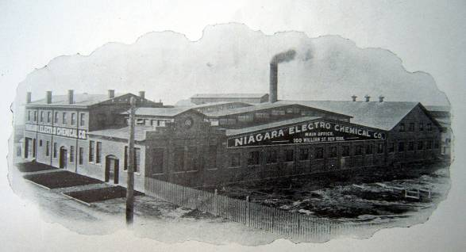

Niagara Electro-Chemical Company. (Located on NFPC land in the Buffalo Avenue area) “This company was formed to work the processes of H. Y. Castner for producing sodium, sodium peroxide, and sodium cyanide. . . . Metallic sodium was made by electrolyzing molten caustic soda just above its melting point. Four rows of 30 pots operated at 1200 amperes and 5 volts per pot, producing 6250 pounds of sodium per day and using 1000h.p. The plant adjoined the Castner Electrolytic Alkali Plant so that it was easy to roll drums of solid caustic soda from one plant to the other.”

following year the Matheson Alkali Company began producing synthetic ammonia and other bleaching products. In 1897, the British-owned Oldbury Electro-Chemical Company set up shop in Niagara Falls making phosphorus, caustic
potash, and other products. Other firms employing electrolysis, such as the National Electrolytic Company, Hooker Electrochemical Company, and the
International Minerals and Chemical

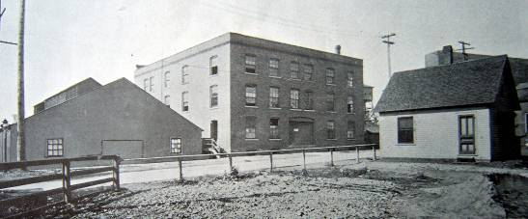

National Electrolytic Company (Located on NFPC land in the Buffalo Avenue area)

Corporation, turned out many other
primary products at Niagara Falls. Chief among them were: potash, used in the manufacture of glass, soap, and fertilizer; hydrogen peroxide, an ingredient in making plastics; acetylene, a colorless gas also used in making plastics and solvents and in torches for welding and cutting
metals; and carbon monoxide, a deadly, odorless gas that despite its notorious reputation is needed to make dry ice. Perhaps there was no better indication of the rise of the chemical industry in Niagara Falls that the fact that at the turn of the twentieth century there were important chapters of both the American Chemical Society and the Electrochemical Society meeting in the city. “The chemical genie is creating new products faster than the historian can record them,” boasted the Union Carbide Corporation.

Electrolysis was also used to produce metals, such as cerium and sodium. Indeed, the first large scale manufacturing company to locate at Niagara Falls once electric power began its abundant flow here was the Pittsburgh Reduction Company, which in 1907 became the Aluminum Company of America (ALCOA). It pioneered the first commercial use of electrolysis to produce aluminum ingots. In 1886, youthful Charles G. Hall, a recent college graduate, discovered a process for producing aluminum inexpensively. One of the most abundant metals on earth, aluminum occurs in nature in bauxite where it is united with other elements. Devising a process that depended on electrolysis, Hall was the first to figure out a way to isolate the metal in large quantities in pure form. In the late summer of 1895, the company established an installation a short distance upriver from the Niagara Falls Power Company,
from which it leased land and obtained electricity. A year later, a second plant went into operation on the edge of the gorge where it received direct current electricity from the Niagara Falls Hydraulic Power and Manufacturing Company station at the foot of the gorge. Both of these huge shed-like complexes—the second plant was the largest structure on the gorge rim--exist today only historic photographs. Lead oxide, a important ingredient in paints of earlier days, was also a prominent Niagara Falls commodity produced by electrolysis.

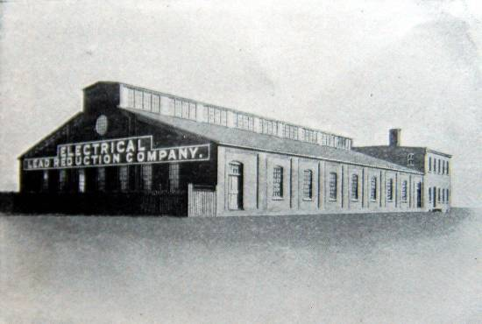

Electrical Lead Reduction Company. “A new process for the reduction of lead by electricity . . . has been conducted at Niagara Falls during the past three years by the Electrical Lead Reduction Company. The chief merits of the invention are the reduced cost of production of pure lead, for all the uses of which it is adapted, and the rapid and economical conversion of the same into various commercial forms.”

Another initial client of the Niagara Falls Power Company was the Oldbury Electro-Chemical Company, which signed a contract for energy and a land lease in 1896. Oldbury’s parent company, Albright & Wilson Limited of Oldbury, England, had for many years manufactured

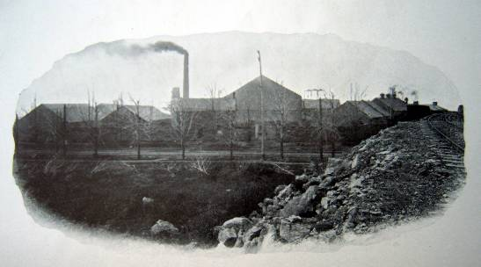

Oldbury Electro-Chemical Company (Located on NFPC land in the Buffalo Avenue area)

white phosphorus, which was used in making matches, pharmaceuticals, metals and other products. Due to the rising protectionist sentiment in America promoted by President McKinley, the British investors thought it prudent to set up a plant in the United States. The availability of cheap and abundant electricity at Niagara Falls led the company to locate here where they would employ the electrolysis process used by the parent company in England. Like other new arrivals at the Falls, the Oldbury firm leased land for its plant directly from the power company. Since there are so few personal accounts of the early buildings of Niagara Falls industries—so many of which have vanished without a trace--it is beguiling to read the remarks of Walter Wallace, a British chemist who came to work for the company in Niagara Falls in 1902. “At the time of the location of Oldbury Electro-Chemical Company at Niagara Falls,” remembered Wallace,

there were already established there plants producing aluminum, carbide, carborundum, caustic and chlorine, all dependent upon the use of electric power, which was for the first time available in the United States at a very low rate and in large quantities.

The Niagara Falls Power Company had purchased all available lands to the east of the Falls along the river and for some miles back into the country. Users of their power were located on these lands. The site of Oldbury Electro-Chemical Company was three miles east of the Falls along the river, on Buffalo Avenue. There were no sewers, pavements or sidewalks, just a dirt road traveling through farm country.

The first buildings erected were the first 90 feet of what is known as the ‘Old Furnace Room’, and buildings for finishing and packing the phosphorous and for shops; also a blacksmith shop and a boiler house. A pump in the boiler house supplied the plant with water drawn from the river. . . . The power from The Niagara Falls Power Company was at 2200 volts transformed into 100 volts on the premises. The furnaces consisted of six 50-kw. Single-phase units, and the carbon electrodes and carbon used in the crucibles were made on the premises. Aluminum phosphate from South American islands, calcium phosphate from Tennessee, and sandstone from northern Pennsylvania, together with coke, were the raw materials used in the furnaces.

In 1899 the manufacture of chlorate of potash was added. . . . This chlorate plant was built to the east of the phosphorus plant, with a transformer room, cell room, first and second crystallizing rooms, grinding and packing room, and a warehouse. With the exception of the grinding room, which was of brick, all of the buildings were of wooden construction with galvanized iron sheet protection on the outside. . . . [In 1902] fire occurred in the wooden cell room, which had been thoroughly contaminated with cell spray from the open cells for the previous three years. The transformer room and cell room and most of their contents were lost, but these buildings were rebuilt of fireproof construction and operation recommenced late in 1903.

Together with chemical compounds, electrolysis was used at Niagara Falls for the production of certain metals other than aluminum. The Cerium Metals Corporation, for example, turned out so-called rare-earth metals of the cerium group. (Cerium itself is a shiny grey malleable metal used in making carbon arc-lighting and glass.)

§ Other Electro-process Industries

Because of the abundant electricity, the concentration of industries producing primary materials needed for many industrial processes, and the closeness to large markets, manufacturers of many types of products set up shop in Niagara Falls in the later nineteenth and early twentieth centuries. “The manufacturing establishments who use the power of Niagara are clean, without smoke, gas or ashes, lauded an early booster.” Among the first goods manufactured here in unadorned, utilitarian structures of often stirring scale (and mostly now over and done) were paper (International Paper Company; Niagara Surface Coating Company);

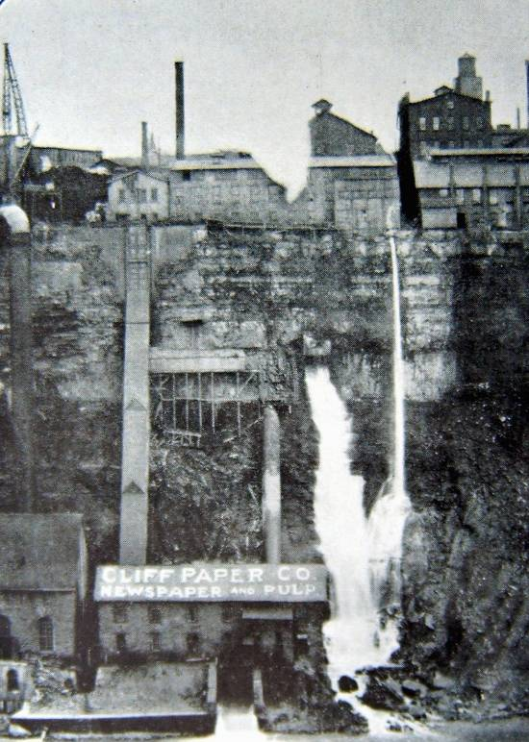

The Cliff Paper Company at the base of the High Bank. This complex, which was a tenant of the Schoellkopf Station, took advantage of its unusual location. “The peculiar features of the plant,” runs a contemporary description, “are that the pulp mill is driven by water power, using water which has been used once under 75 feet head. After doing duty under this head, the tail water is delivered to a penstock running down 125 feet further and is utilized in horizontal turbine Leffel wheels giving about 2500 h.p. These wheels are direct connected. The power is therefore used as economically as possible. The pulp is brought to the paper mill above the bank by a chain carrier. The paper machines are driven by electric motors supplied with current from generators direct connected to 300 h.p. Leffel horizontal wheels using tail water from the wheels. The pulp mill and paper mill are connected by an inclined railway used for carrying freight and passengers.”

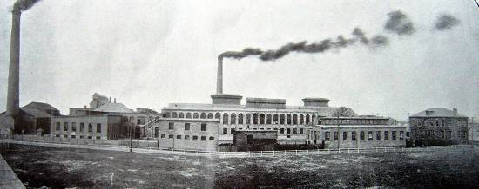

International Paper Company. “The principal mill buildings, built of brick, stone and iron, and of the most substantial construction, would cover an area equal to that between Forty-second Street and Central Park, New York City, from Fifth to Sixth Avenues, in the same city, and surrounding them would be many stores, houses and miscellaneous buildings. Hundreds of dwellings and tenements would be necessary to complete the picture, all belonging to the company.

newsprint (Pettebone-Cataract Paper Company; Cliff Paper Company), silverware (Oneida Community, Limited) lamps (Electro Lamp Company), office supplies (Carter-Crume Company; Moore Business Forms), feed (Myers & Company), machinery (Dobbie Foundry and Machine Company), lumber (Charlotte Haebaerle Company; Spencer-Wicker Lumber Company; J. H. Cook & Company), textiles (Cataract Hair Cloth Company), suspenders (Doran Brothers & Martin Company), clothing fasteners (Francis Hook and Eye and Fastener Company) railroad equipment (MacPherson Switch and Frog Company), flour (Niagara Falls Milling Company; Cataract Milling Company), and cereal (Natural Food Conservatory, makers of Shredded Wheat). Indeed, Niagara Falls factories labored incessantly to supply many of modern man’s physical needs.

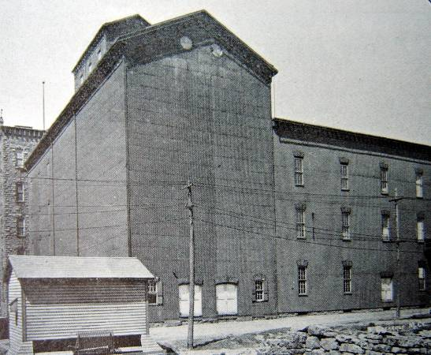

Central Mill of the Niagara Milling Company (Located on the High Bank)

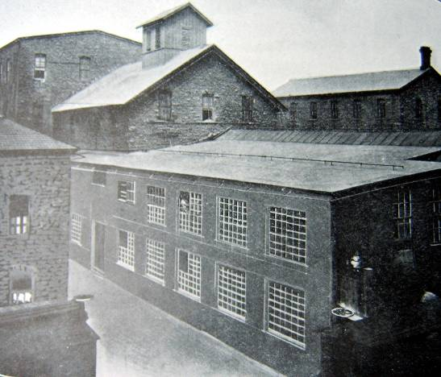
Cataract City Milling Company (Located on the High Bank)

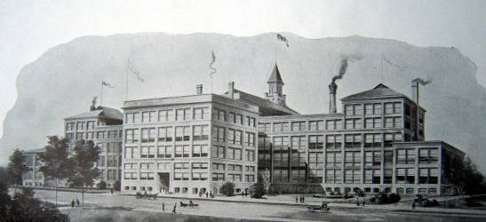

The Natural Food Company. “The Natural Food Company manufactures the products known as Shredded Wheat Biscuit and Triscuit. In the manufacture of Triscuit, the first commercial use of electricity for baking has been made.
“The factory of the Natural Food Company is situated on Buffalo Avenue, between Fourth and Sixth Streets, occupying an entire block. This location is in the heart of the residence section of the city. It has a frontage of 900 feet on the Niagara River and adjoins the State Reservation, so that other manufacturing industries cannot encroach upon the plant. The absolute cleanliness in surroundings, required in the process of the manufacture of a pure food, is thus secured. The building is 466 feet long by 66 feet deep, and consists of a main building with four connecting wings.
“Upon entering the building one steps directly into a large foyer or reception hall, where guides are at hand for the purpose of conducting parties through the pant. Just off the foyer are two electric elevators used for conveying visitors to the roof garden, or observatory, from which a magnificent view of the upper rapids and of the industrial section of the city may be obtained.” The plant was demolished in 1956; the office section came down in 1976.

§ Transportation

The development of industry at Niagara Falls, of course, depended on a system of transportation to move raw materials and goods in and out of the city. Despite the fact that the city stands beside a great river, the waterway had only limited usefulness as an artery of transportation. For several miles upriver from the Falls, the river was too shallow to accommodate large vessels. In addition, of course, the Falls precluded any water connection with Lake Ontario and the St. Lawrence River. The one scheme attempting to join the upper and lower portions of the river on either side of the Falls by a canal never got beyond an initial phase. In the early 1890s, another Niagara Falls futurist, William T. Love, proposed building such a canal that could be used for both hydroelectric power generation and for shipping. It was to be part of a utopian scheme that would see the rise of an ultramodern city at the northern end of the canal. “Model City” the name he chose for this new capital of industry was, said Love, “destined to become one of the greatest manufacturing cities in the United States.” Construction of the waterway ended after less than two miles had been dug northward from the upper river. In the 1920s, this remnant of Love’s dream sadly became a toxic waste dump that was in use until the 1940s. The subsequent history of the Love Canal in the 1970s and 1980s has, of course, made its name synonymous with the modern day evil of industrial pollution.

The railroad allowed Niagara Falls to become a great industrial center. The first railroads into the village were the Lockport & Niagara Falls, which was incorporated in 1834, and the Buffalo & Niagara Falls, which began operations between its namesake cities in 1836. The former came in from the north near the gorge and the later from the east along what became Buffalo Avenue; the two lines met at the northeast corner of Falls and Second Streets, which would serve as the Niagara Falls station for over a hundred years. The two lines eventually were joined under the New York Central Railroad; the railroad (along with the hydraulic canal) effectively bisected the city until service ended in 1964. Elements of this railroad line that still remain include the steel bridges over Portage Road (here still paved in brick) and Tenth Street, retained to serve the Shredded Wheat plant, and trackage through the former Hooker Chemical plant along Buffalo Avenue, retained for access to that plant. The former New York Central line through the northern section of the city, constructed circa 1850, continues in use with traffic over the bridge to Canada. The original railroad bridge across the gorge was built in the 1850s. This important bridgehead attracted other railroads to the area. The Erie (under the name Suspension Bridge & Erie Junction) opened its line to Niagara Falls in 1871, running parallel with the New York Central along Buffalo Avenue before turning northward between Eighth and Ninth Streets. The Lehigh Valley arrived in the area not on its own line, but over trackage rights on the New York Central in 1896. The Lehigh Valley had its own large yard between Main and Ninth Streets in the city’s north end. In 1892, the Niagara Falls Power Company formed the Niagara Junction Railway, to facilitate transportation to industries locating on its land. The railroad was electrified in 1913, meaning that the locomotives drew their power from overhead wires, and remained so until the 1970s. The railroad remains in service, now operated by standard diesel locomotives; the former engine house for the electric locomotives still stands on the east side of Hyde Park Boulevard, south of Buffalo Avenue, now used for other purposes.

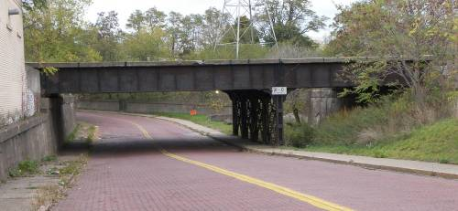

Former New York Central Railroad deck girder bridge across Portage Road.

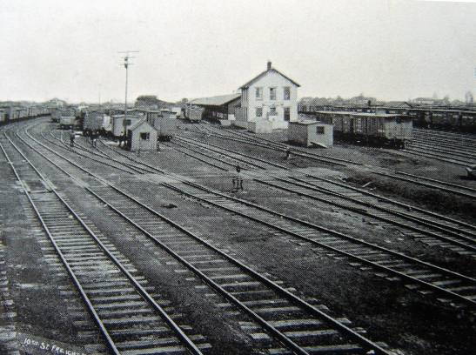

New York Central North End Yards (Located in the North End of town)

. By the middle of the twentieth century, when Niagara Falls industries were at their peak, 2000 freight cars a day passed through the city. Over three quarters of the raw materials required by the various electro-process industries came to the area by rail. Locally, the electric powered Niagara Junction Railway, continued to move materials in freight cars and tanker cars between plants over forty miles of track in the Buffalo Avenue-Packard Road area. It was also used to switch cars to and from the mainline roads.

With the development of an efficient highway network in the twentieth century, much of the materials and products coming in and going out of Niagara Falls businesses were transported by truck. By the 1950s, twenty per cent of such items went by truck service. Moreover, trucks took care of most of the intra-city transport of primary materials from producers to nearby manufacturers, as well as the movement of materials within a single plant. Moreover, most of the output of Niagara Falls industries was destined for industrial users, not for sale directly to the public.

In addition to vehicular and rail car transport, some primary commodities produced by Niagara Falls electro-process industries left the area via pipeline. Acetylene gas was one such product that flowed to out-of-town customers through a pipeline system.

§

What is amazing to the early twenty-first century visitor to Niagara Falls is how little of the physical evidence of the city’s impressive industrial past remains standing. Vanished are the major monuments that defined the industrial era here: the Hydraulic Canal and railroad line that came through the heart of downtown; the historic Schoellkopf Station; most of the Adams Power Plant; the great shed-like buildings at High Bank basin; the pioneering Carborundum plant; the mammoth Shredded Wheat plant; and nearly all of the early industrial structures on the land leased from the Niagara Falls Power Company. Within a span of less than two centuries, Niagara Falls has passed from a fledgling village in a pristine wilderness to an eminent center of industry into a twilight era of dwindling production and manufacturing. The process of decline, which we now see began already in the 1950s, has been often studied. It was due to many factors, including the attraction of lower labor costs elsewhere, the cost of upgrading aging facilities, the realization that the Niagara River’s potential for producing electricity was indeed finite, changing rates for electrical power, the rise of foreign competition, and economic globalization. The story repeated itself in other “Rust Belt” cities in the Northeast, but perhaps nowhere else is the disappearance of historic evidence of a once great economy—in 1929, on the eve of the Great Depression, the city assessor identified 1629 factory buildings--so striking. An encampment for industry, Niagara Falls today preserves little above-ground evidence of its transient visitors’ stay. The following section of this report inventories what appears to remain from the days when Niagara Falls was the one of the largest electro-process industrial centers in the world. The inventory is arranged according to the three geographical areas that became home to the city’s electro-process industries.

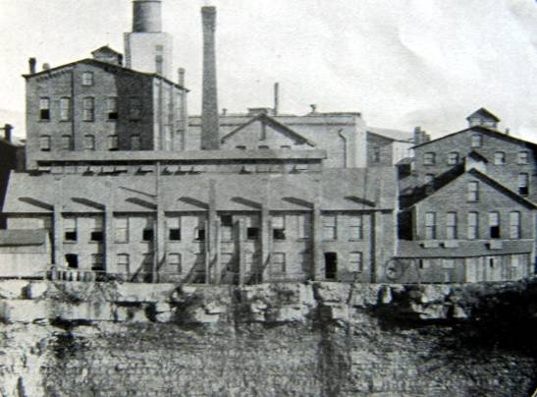

Oneida Community, Limited, High Bank Plant. The company, which made silver plated utensils, turned out 50,000 spoons per day in the early twentieth century.

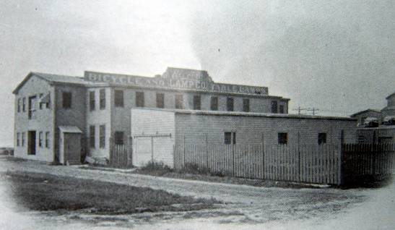

Electro Lamp Company. (Located on NFPC land in the Buffalo Avenue area.) The company manufactured portable acetylene lamps.

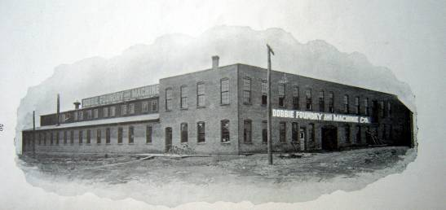

Dobbie Foundry and Machine Company. (Located on Portage Road, north of Buffalo Avenue.) The firm made boilers and structural metal components in its 40,000 square foot factory. Some early buildings may remain on the site.

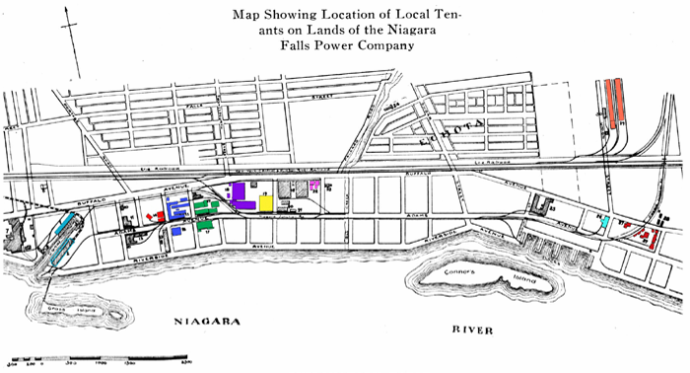

SURVEY OF REMAINING HISTORICAL INDUSTRIAL SITES

THE HIGH BANK INDUSTRIAL DISTRICT

The High Bank was the industrial area at the top of the Niagara River gorge, just north of the Falls and at the western end of the hydraulic canal through the city. Originally built in the 1850s, it was not until Jacob Schoellkopf of Buffalo and others bought the canal in 1877 that industry began to develop at this site. Electrical power began to be supplied in the 1880s from a generating station at the bottom of the gorge that was continuously expanded into the 1920s. The industrial facilities were grouped around the basin at the end of the hydraulic canal. The principal business and number-one user of hydraulic power on the High Bank was the aluminum manufactory of the Pittsburgh Reduction Company (1896), later the Aluminum Company of America or ALCOA, which had two large plants here and whose massive towers dominated the cityscape. Other firms here by 1907 included the National Electrolytic Company (chemicals); the Cliff Paper Company and the Pettebone-Cataract Paper Company (wood pulp and paper); the McGarigle Machine Company (wood pulp machinery and miniature locomotives); and the flour mills of the Cataract City Milling Company and the Niagara Falls Milling Company. Later plants included the William A. Rogers Company, later Oneida Limited, which manufactured silverware and cutlery, and the Niagara Falls Wallpaper Company. All of these businesses had closed or relocated by 1949, when ALCOA closed its last plant here, ending nearly a century of industrial production on the High Bank. The industrial buildings here had long been considered an eyesore and an embarrassment to the city, and all were gone by 1951, leaving only the Schoellkopf power plant; in 1956 that plant was badly damaged by a rock slide from the gorge wall, and except for some retaining walls was subsequently demolished. (A section of the hydraulic canal retaining wall also remains west of Second Street.) Signage with photographs should be installed around this site to inform visitors and residents of the important industrial concerns that once dominated the city.

THE BUFFALO AVENUE INDUSTRIAL DISTRICT

FORMER SHREDDED WHEAT COMPANY

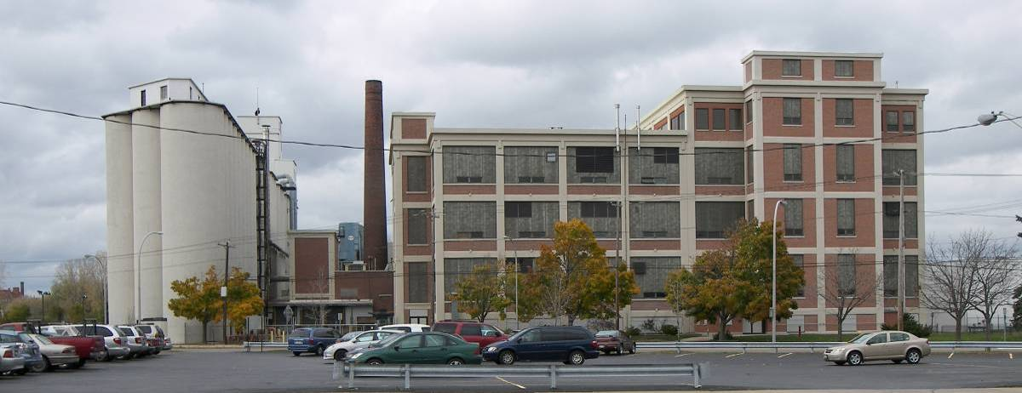
Former Shredded Wheat Company factory and elevator, 816 Rainbow Boulevard.

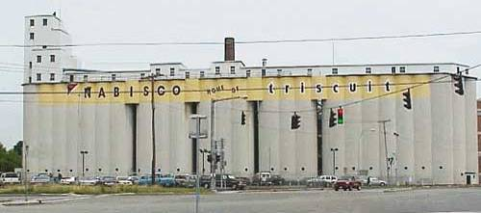
Former Shredded Wheat Company elevator, west elevation. ShovelReady.com

The Natural Foods Company built its first factory on Buffalo Avenue in 1901, and later changed its name to the Shredded Wheat Company, after its principal product. The firm constructed this concrete frame factory building and adjacent concrete grain elevator as its second plant in 1912-1920 at 816 Rainbow Boulevard; unlike the first, this had direct access to a railroad line. The company was taken over by Nabisco in 1928. The original plant was demolished in 1956 and 1976. Production ended at this plant in 2001. This is an outstanding example of the concrete frame industrial building, and along with the massive grain elevator, constitutes the most significant reminder of the city’s industrial heritage remaining in downtown. This facility should be documented and evaluated for reuse.

MOORE BUSINESS FORMS, INC.

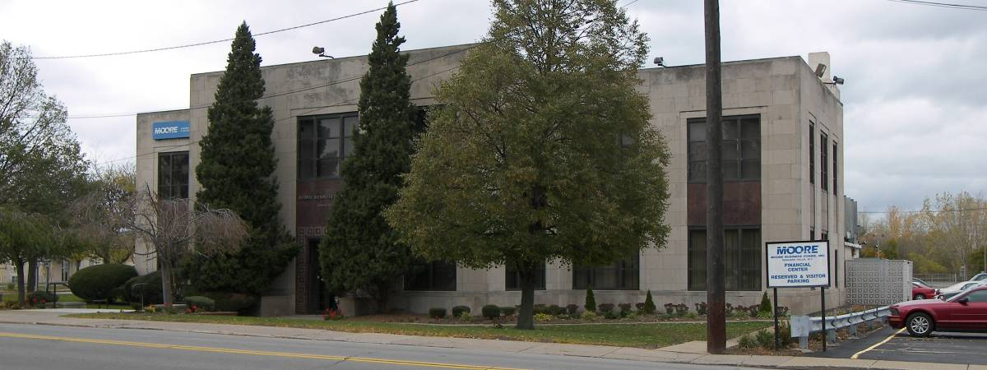
Moore Business Forms, Inc., 900 Buffalo Avenue.

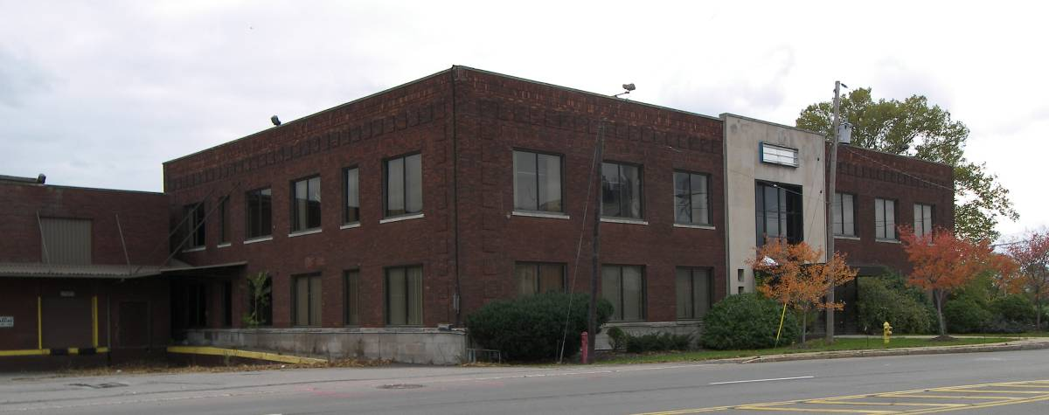
Former Moore Business Forms, Inc., originally A. S. Gilman Printing Company, 1001 Buffalo Avenue.

Moore Business Forms began business in Niagara Falls in 1883. The main plant was located on Highland Avenue, but was demolished in 1992. This building was built in 1912 as the brick and concrete factory of the Niagara Chocolate Company, which made the chocolate used in the Shredded Wheat Company’s Triscuits. That company did not remain in business long, and the building was used by other industries before becoming the administration building of Moore Business Forms. The building was expanded and the façade modernized in the 1950s. For many years Moore Business Forms also occupied the circa 1925 building, originally occupied by the A. S. Gilman Printing Company, across the street at 1001 Buffalo Avenue, but it is now vacant.

FORMER TRANSFORMER HOUSE, NIAGARA FALLS POWER COMPANY

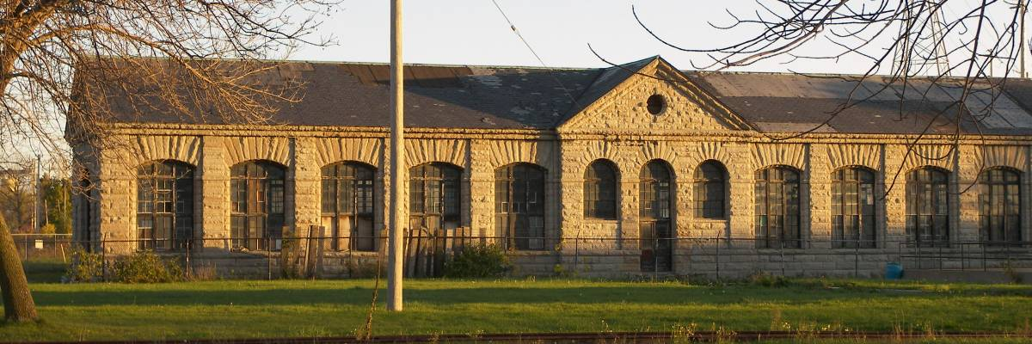
Former transformer house, Niagara Falls Power Company, west elevation.

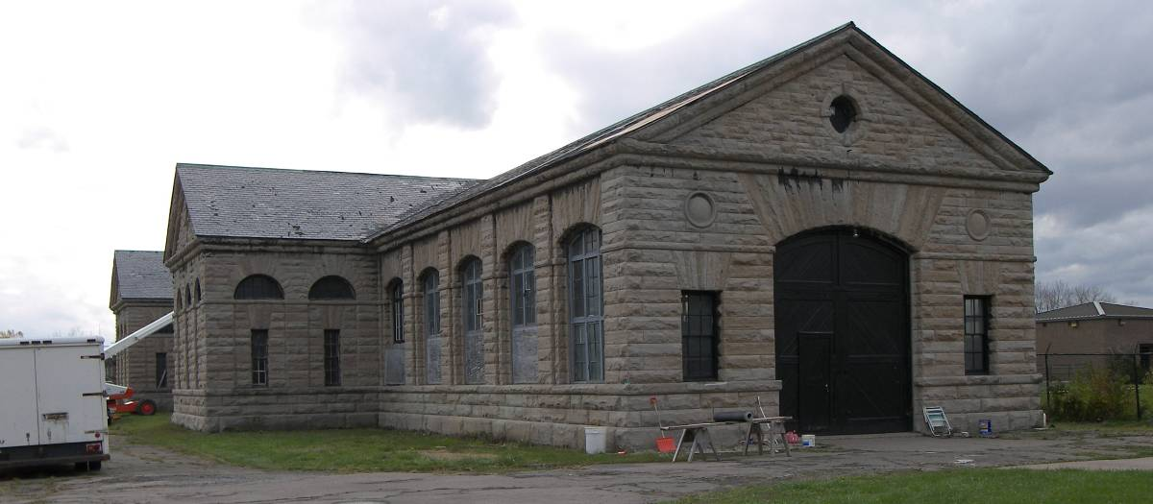
Former transformer house, Niagara Falls Power Company, view from northeast.

This gray limestone structure was built circa 1895 as the transformer house for the Niagara Falls Power Company, and was designed by the prestigious New York architectural firm of McKim, Mead & White. The building once stood on the east side of an intake canal from the river (now filled in); the original powerhouse stood on the west side of the canal. In 1904 a second Powerhouse was built behind the transformer house. Electrical power was generated by the fall of water from the canal 177 feet down into turbines below; water exited through a tunnel below the city into the gorge. The transformer house contained equipment that adjusted the electrical output from the powerhouses for use in local industries. The powerhouses were placed in standby service in the 1920s and demolished in 1964. However, the transformer house was retained for the power converters it housed that were still needed by local industries with old 25-cycle equipment. Those industries have now closed, but the transformer house remains, perhaps the most architecturally and historically significant building in the city. The preservation of this major landmark, listed on the National Register of Historic Places, should be a top priority. The building could be used as a museum to celebrate the industrial heritage that created the City of Niagara Falls.
FORMER CARBORUNDUM COMPANY

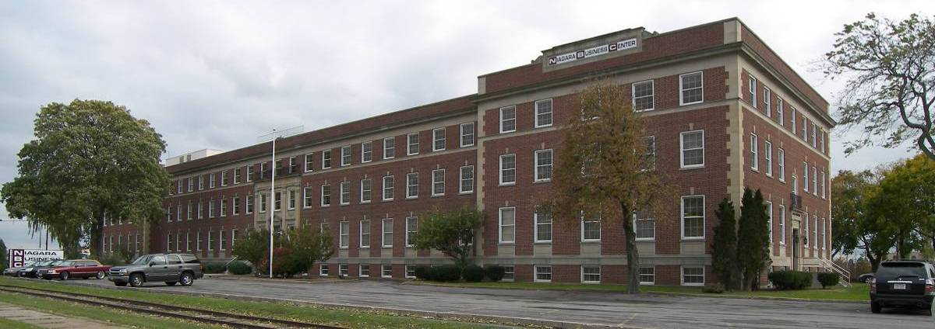
Former office building of the Carborundum Company, now the Niagara Business Center, 1625 Buffalo Ave.

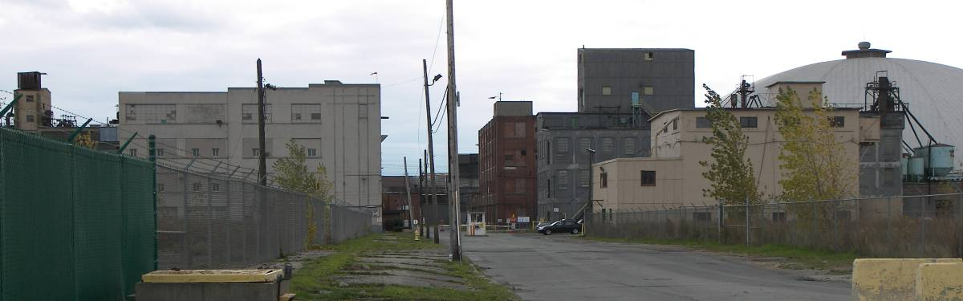
The remiang section of the former factory complex of the Carborundum Company, now Washington Mills Electro Minerals Corporation, 1801 Buffalo Ave.

The Carborundum Company was founded by Edward G. Acheson to manufacture silicone carbide (carborundum), an extremely hard ceramic abrasive. Acheson brought the firm to Niagara Falls in 1894 and built its factory at the southeast corner of Buffalo and Carboundum Avenues. The company grew rapidly, and by the 1920s it was the largest employer in the city. By World War I the factory had expanded south across Adams Avenue and east along Riverside Avenue to Chemical Road, eventually acquiring the original Buffalo Avenue plant of the Pittsburgh Reduction Company (later Aluminum Company of America, or ALCOA), which ceased production in 1919. In 1924 the company built a new three-story office building at 1625 Buffalo Avenue, which still stands. The Carborundum Company was sold to Kennecott Copper in 1977, and then to Standard Oil in 1981. Not long after, operations at the Niagara Falls facilities were discontinued, and most of the buildings in the vast complex have been demolished. Portions of Plants No. 2, No. 6 and No. 7 are evidently still intact along Adams Ave. Some of these buildings may predate World War I, and may include buildings from the original plant of the Pittsburgh Reduction Company (ALCOA). These surviving buildings are now the property of Washington Mills Electro Minerals Corporation, 1801 Buffalo Avenue, and the New Carborundum Corporation. All of these remaining buildings should be documented, and their owners made aware of their significance.

FORMER ACHESON GRAPHITE COMPANY

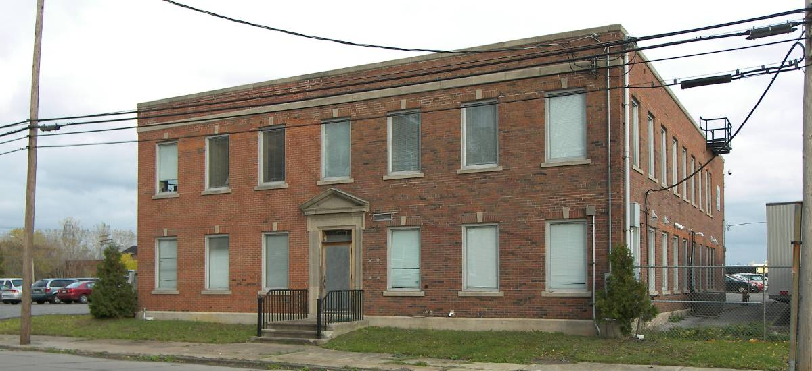
Former Acheson Graphite Company office building, Portage Road.

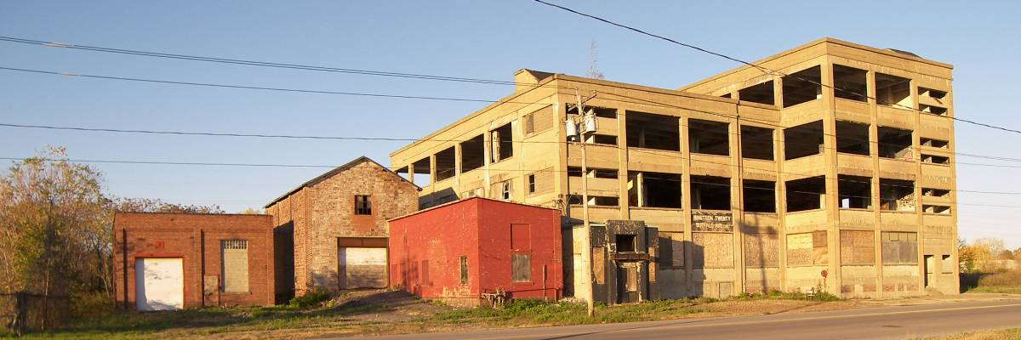
Former Gredag Plant, Acheson Graphite Company, 1920 Buffalo Avenue.

The International Acheson Graphite Company was founded in 1899 by Edward G. Acheson to manufacture solid graphite, dry graphite powder, lubricants, electrodes and anodes. Acheson left the Carborundum Company, which he had founded earlier in the decade, to form this concern. In 1899 construction began on the factory complex at the southeast corner of Buffalo Avenue and Portage Road. The plant was expanded considerably during World War I. Acheson Graphite merged with National Carbon in 1930, and eventually became the Carbon Products Division of Union Carbide Corporation, which closed the Buffalo Avenue plant in 1982. At the time of closure, the facility still used 25-cycle power. The entire factory complex on the south side of Buffalo Avenue has been demolished, with the exception of the circa 1925 two-story office building on Portage Road; the site is now used as an employee parking lot for the Seneca Niagara Casino. On the north side of Buffalo Avenue, the concrete frame Gredag plant (1914-1920) still stands, though the windows have recently been removed; adjacent are several small related buildings of brick and tile. These remaining buildings should be documented and evaluated for reuse.

OLIN CORPORATION

The historic sites of this company, at 2725 Buffalo Avenue, have few old buildings remaining. The Castner Electrolytic Alkali Company was established circa 1897, on the south side of Buffalo Avenue, to the east of the Carborundum plant. Plant No. 1 was soon outgrown, and the complex was expanded to east, leapfrogging over Niagara Electro-Chemical Company (now DuPont) to the east side of Chemical Road (26th Street). The plant produced chlorine and caustic soda from rock salt (sodium chloride), and became successively the Mathieson Alkali Works, Olin-Mathieson Chemical, and now the Olin Corporation, which produces chlorine, bleach and caustic soda. The last of the large factory buildings has recently been demolished, although some small brick and concrete-frame buildings in the rear of Plant No. 2 still stand along Adams Avenue, west of Alundun Road. These remaining buildings should be documented.

E. I. DUPONT DE NEMOURS AND COMPANY

The Niagara Electro-Chemical Company was founded in 1895 and built its plant at the southwest corner of Buffalo Avenue and Chemical Road (26th Street). It later became the Roessler & Hasslacher Chemical Company, and in 1930, E. I. du Pont de Nemours & Co., Inc., which, still operates the facility. The present plant may contain buildings dating back to the World War I era. The facility is dominated by a large brick building on the south side of Buffalo Avenue that probably predates World War II; other buildings behind are not easily visible from the street. Most of the extensive facility runs along the south side of Adams Avenue, and is likewise manufactures alkalies, chlorine and inorganic chemicals. The early buildings remaining in this facility should be documented.

ALOX CORPORATION

The Alox facility at 3943 Buffalo Avenue is one of the smaller early industrial sites still extant in the city. This was originally the Niagara Vegetable Oil Corp., manufacturers of hydrogenated oils, who built this plant at the southwest corner of Buffalo Avenue and Iroquois Street in 1916. The firm became the Alox Corporation ten years later. Of the buildings remaining on the site, the 1938 concrete block office building with Art Moderne details is particularly notable. The entire facility should be documented.

OCCIDENTAL CHEMICAL CORPORATION

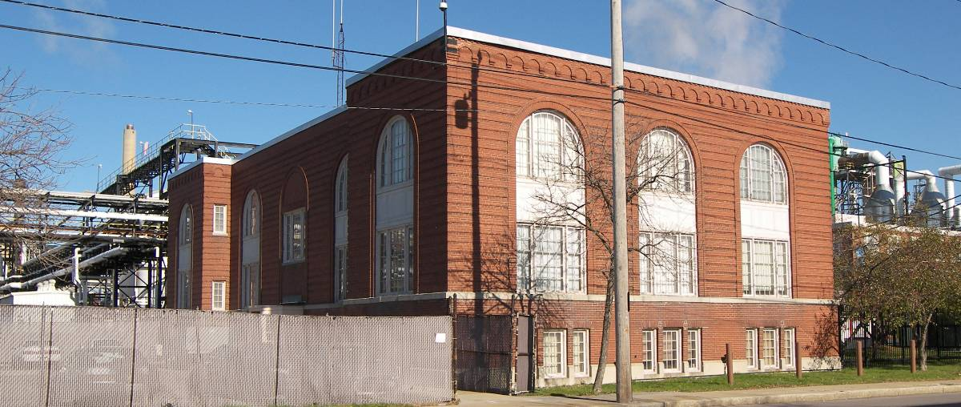
Former Hooker Electro-Chemical Company office building on Buffalo Avenue.

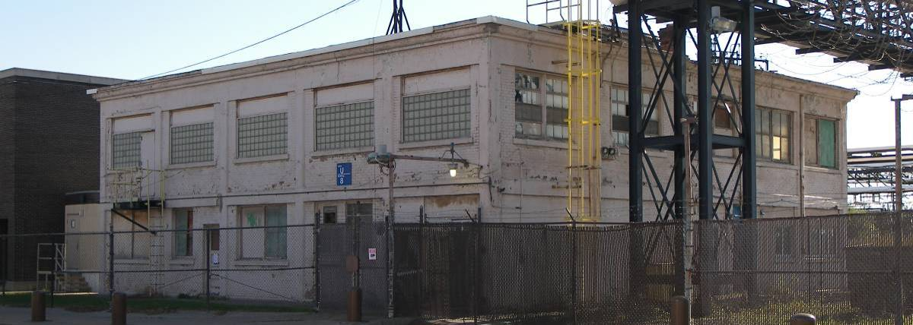
Former Roberts Chemical Company building on Buffalo Avenue.

This massive electrochemical complex, which extends over approximately 160 acres, is an amalgamation of several earlier adjacent companies. The facilities on the north side of Buffalo Avenue were originally the Development and Funding Co., was founded in 1903 by Elon H. Hooker. Its original plant burned in 1910 and was rebuilt under the new name of the Hooker Electrochemical Company, and acquired the adjacent du Pont plant 1917. Of the numerous brick buildings still on the site, an office building with round-arch bays and the power house, both circa 1920, are the most visible from public property. The Roberts Chemical Company constructed its factory at the southwest corner of Buffalo Avenue and Union (47th) Street around 1901. The firm became the Niagara Alkali Co. and was later absorbed by Hooker. A circa 1910 concrete frame building facing Buffalo Avenue is evidently the only early building remaining on the site. The Oldbury Electro-Chemical Co. was established in 1897 to manufacture phosphorus. Its plant was located on the south side of Buffalo Avenue, east of the Roberts Chemical Company and on both sides of the Niagara Junction Railway, which crossed the avenue at this point. This firm later absorbed the Phosphorus Chemical Co. on north side of Buffalo Avenue and was eventually merged into Hooker. No early buildings remain on the site. All of the remaining early buildings should be documented, and the owner made aware of their significance.
PRAXAIR

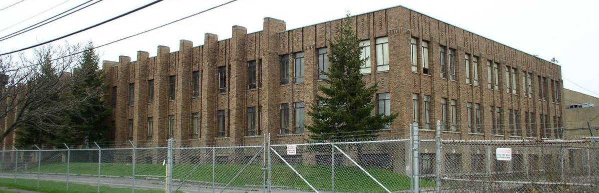
Former Union Carbide office building and research laboratory, 4501 Royal Avenue. This Art Deco landmark, along with several adjacent buildings in the historically significant research complex, was recently demolished as part of the clearance of the entire Union Carbide site. Photo courtesy of Thomas Yots.

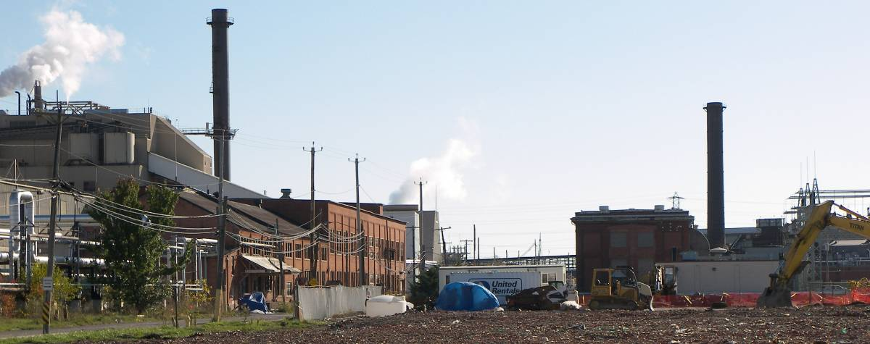
Some of the early Union Carbide buildings still stand along 47th Street.

Praxair’s former Union Carbide facility is one of the most significant industrial sites in the city, but it is fast disappearing. Founded in 1896 as the Acetylene Light, Heat and Power Co., the firm became Union Carbide two years later. It constructed its plant on the east side of Union (now 47th) Street, north of the New York Central Railroad line. Some of the large brick buildings on the original site are still standing, and may date to the early twentieth century. The firm built its Metals Research Laboratories at the southwest corner of Royal Avenue and Union Street; the complex grew to fourteen buildings, the centerpiece of which was a 1933 Art Deco building at 4625 Royal Avenue. Owing to the fact that over 500 patents to inventors who worked here, this facility was named an ASM Historical Landmark in 1986; unfortunately all the buildings on this site were recently demolished. The present active section of the plant was built in the 1980s. In 1989 the facility became Union Carbide Industrial Gases, and was spun off in 1992 as Praxair, which is in the process of clearing the site of all the old Union Carbide buildings. All of the early buildings still remaining should be documented, and the owner made aware of their significance.
NIACET CORPORATION

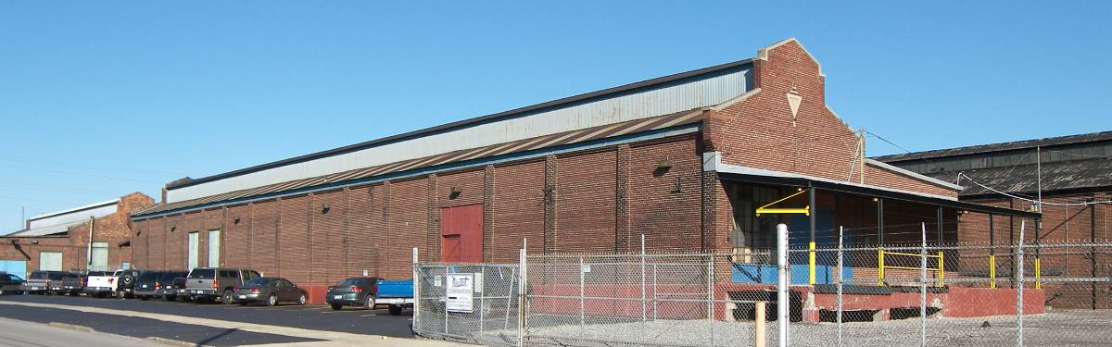
Three of the extant early Niacet Corporation buildings feature clerestory roofs.

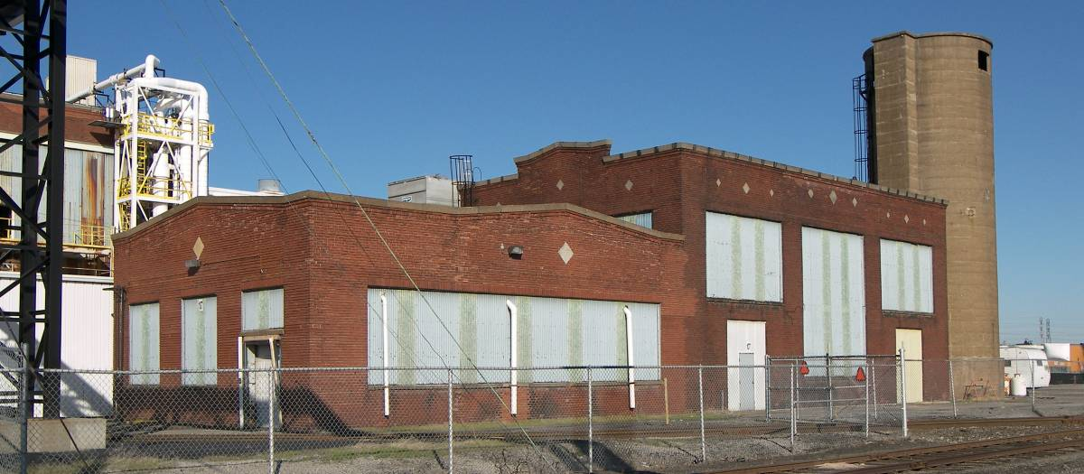
An early Niacet building. The inset concrete diamonds are a unifying feature on many of the buildings.

The Niacet facility along the east side of 47th Street has one of the most notable industrial complexes remaining in the city. Niacet Chemicals Corporation was formed in 1925 to manufacture chemicals with acetylene; the name was derived from Niagara acetylene. Part of Union Carbide for many years, it became an independent company in 1978; it is now the largest producer of metal acid salts on the continent. There are about eight early brick buildings on the site, most appearing to date to the 1920s. Three of these buildings are long and narrow, with clerestory roofs, a rare survival in Niagara Falls. Behind one of the buildings is a pair of very old railroad tank cars, which, if no longer needed by the company, would be ideal candidates for inclusion in a local industrial heritage museum. All of the early buildings still remaining on site should be documented, and the owner made aware of their significance.

MISCELLANEOUS INDUSTRIAL SITES

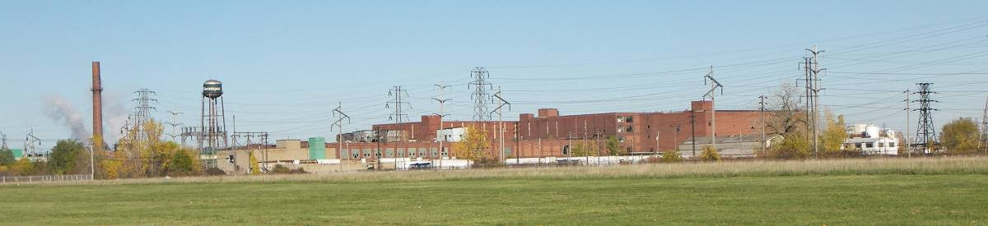

The area west of 47th Street and south of Packard Road, now owned by the Niagara County IDA, may contain early industrial buildings, and should be accessed and evaluated.

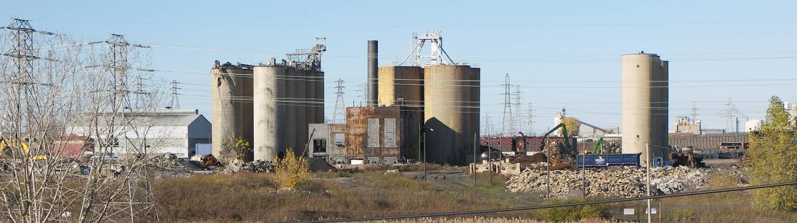

The former Carbide Graphite facility, 4861 Packard Road, is undergoing demolition. The remaining structures should be documented before removal.

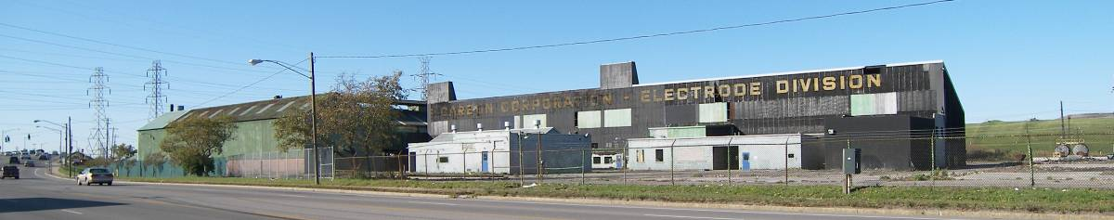

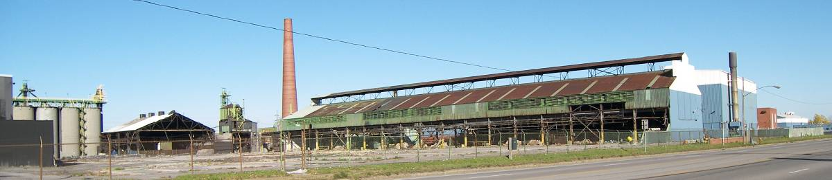

The former Great Lakes Carbon facility, 6000 Niagara Falls Boulevard, is undergoing demolition. The remaining structures should be documented before removal.

THE HIGHLAND AVENUE INDUSTRIAL DISTRICT

FORMER U. S. LIGHT AND HEAT CORPORATION (USL)

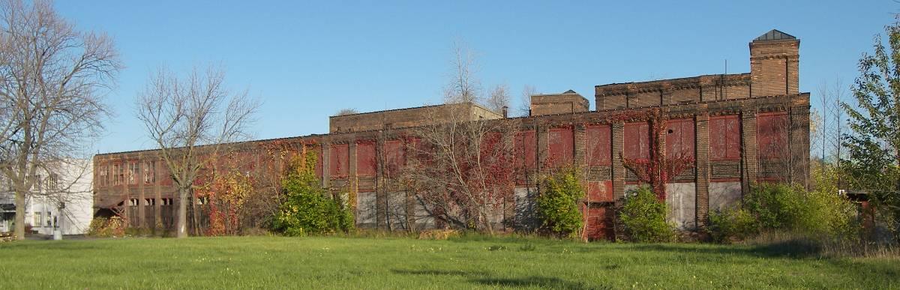
Southern section of the former U. S. Light & Heat Company, now abandoned. Highland Avenue façade.

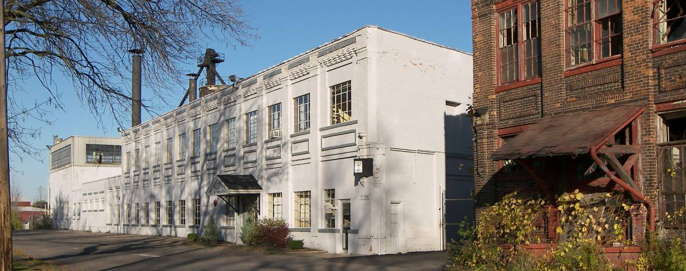
Northern section of the former U. S. Light & Heat Company, now the Tulip Corporation, 3125 Highland Ave.

This is the oldest surviving industrial complex in the City of Niagara Falls. The U. S. Light & Heating Company (USL) began construction on its extensive two-story brick factory here in 1910 and continued to expand it through the end of the decade. Most of the buildings of this period appear to have been little altered; thus this plant has great significance as perhaps the most intact industrial complex remaining in the City of Niagara Falls. The firm originally manufactured lighting devices, storage batteries, electric self starters for automobiles & electric welders, but later shifted to batteries exclusively. In 1942 the facility became the Auto-Lite Battery Corporation, and then Prestolite in 1964. Production in the southern section of the complex evidently had ceased by 1980. The Tulip Corporation, which manufactures battery industry products with recycled plastic, now occupies the northern section of the facility, and the south section is vacant and owned by the city. The entire complex should be documented and evaluated for reuse.

FORMER NATIONAL CARBON CORPORATION

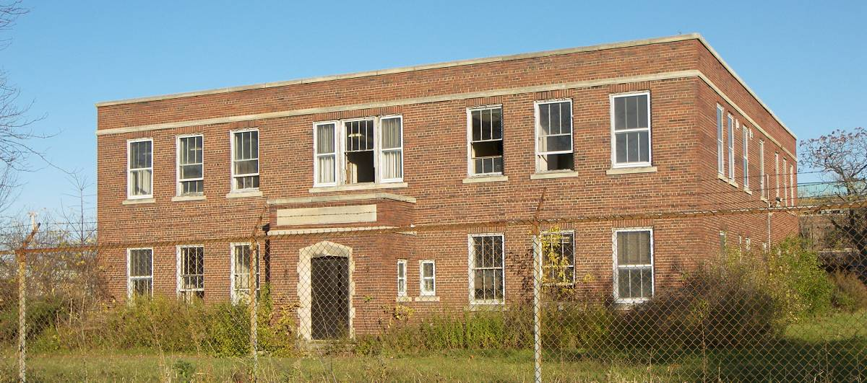
Former National Carbon Company office building facing Highland Avenue.

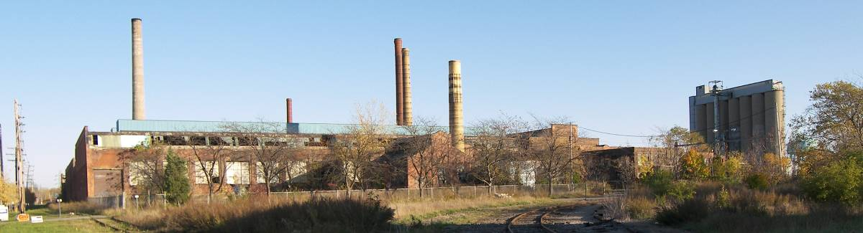
The extensive former National Carbon Company factory complex 2001 College Avenue.

This extensive complex was established in 1910 by the National Carbon Company of Cleveland for the production of carbon electrodes. It was merged into the Union Carbide and Carbon Corporation in 1917. It subsequently grew to be one of the largest industrial facilities in the city, and may be the largest early facility still extant. The enormous scale of the remaining buildings is a strong testament to the city’s industrial golden age. In the 1980s the vacant plant was sold to Niagara Vest, Inc., and the property subdivided. The circa 1915 office building and two adjacent International style buildings, which face Highland Avenue, became the College & Highland Industrial Park; the rest of the site has gone largely unused. Described as “a long vacant eyesore,” the future of these buildings may be in doubt.
The entire complex has great significance and should be documented and evaluated for reuse.

GLOBE METALLURGICAL INC.

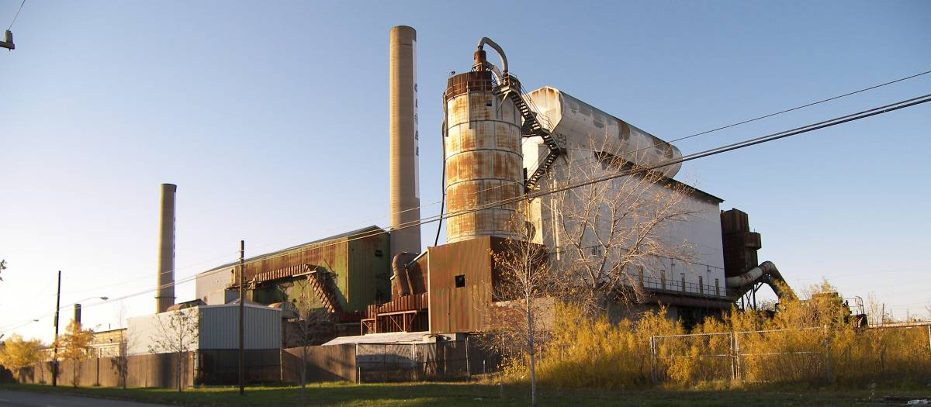
The former Pittsburgh Metallurgical Company, north side of College Avenue east of Highland Avenue.

This facility was originally built in 1919 as the Pittsburgh Metallurgical Company, initially for the manufacture of steel alloys. Focus eventually shifted to chrome and silicon alloys used in the production of stainless steel and electrical steel. The company was greatly expanded during World War II, and much of the facility may date from this period and later. It was eventually taken over by Globe Metallurgical, the largest producer of silicone metal in the nation. The plant was closed in 2003, but now (late 2007) there is an effort to reopen the facility to resume the production of silicone. The early structures on the site should be documented.

TREIBACHER SCHLEIFMITTEL NORTH AMERICA INC.

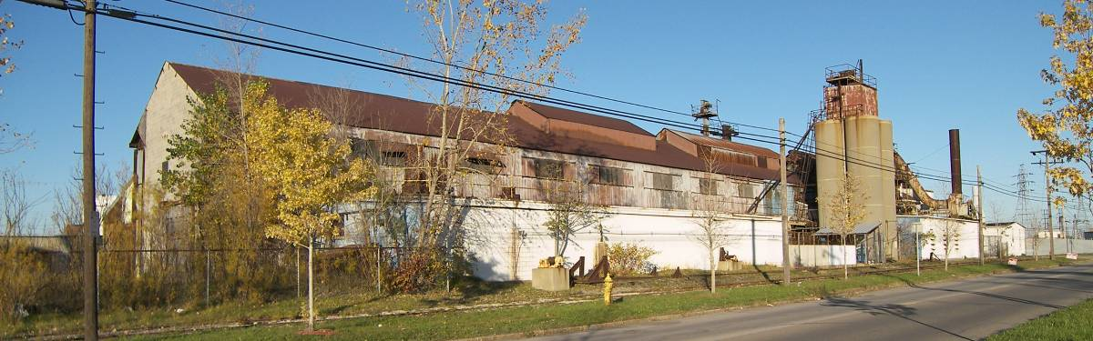
The former General Abrasive Company, 2000 College Avenue.

This facility was established circa 1917 by the General Abrasive Company for the manufacture of abrasive materials. It is now owned by Treibacher Schleifmittel North America Inc. The early structures on the site should be documented.

BIBLIOGRAPHY

Adams, Edward Dean. Niagara Power: History of the Niagara Falls Power Company, 1886-1918. Niagara Falls: privately printed, 1927.

Arnot, Raymond H. “The Industries of Niagara Falls,” Popular Science Monthly, (October 1908), 306-318.

Beveridge, Charles, and Francis Kowsky. The Distinctive Charms of Niagara Scenery: Frederick Law Olmsted and the Niagara Reservation, exh. cat., Niagara Falls, NY: Castellani Art Gallery of Niagara University, 1985.

Bowden, Mary Ellen. Chemistry is Electric! Philadelphia: Chemical Heritage Foundation, 1997.

“Building Operations Very Brisk,” Daily Cataract Journal, January 4, 1901, 1.

Clinton Brown Company Architects. City of Niagara Falls Intensive Level Survey of Historic Resources in the Downtown Neighborhood. Niagara Falls, NY: 2005.

Dow, Charles Mason. Anthology and Bibliography of Niagara Falls. Albany, 1921.

_______. The State Reservation at Niagara, A History. Albany: State of New York, 1914.

Dunn, Edward T. A History of Railroads in Western New York. Buffalo: Western New York Heritage Press, 1996.

Evans, Gail Edith H. “Storm Over Niagara: A Study of the Interplay of Cultural Values, Resource Politics, and Environmental Policy in an International Setting.” Unpublished Ph.D. dissertation, University of California, 1991.

Dumych, Daniel M. Niagara Falls. 2 vols. Dover, NH: Arcadia Publishing, 1996.

Feder, H. William. The Evolution of an Ethnic Neighborhood that Became United in Diversity: The East Side, Niagara Falls, New York, 1880-1930. Amherst, NY: BMP, Inc., 2000.

Gardiner, William C. “Pioneers on the Niagara Frontier In Power and Electrochemistry,” Proceedings of the Symposium on Selected Topics in the History of Electrochemistry, 78(1978), pp. 413-431.

Gawronski, Brett, Jana Kasikova, Lynda Schneekloth, and Thomas Yots. The Power Trail: A History of Hydroelectricity at Niagara. Buffalo: Western New York Wares, 2006.

Graham, Lloyd. Niagara County. New York: Duel, Sloan and Pierce, 1949.

History of Niagara County. New York. New York: Sanford and Co., 1878.

Harrison, Jonathan Baxter. The Condition of Niagara Falls. Niagara Falls, 1882.

“History of the City to Date,” Niagara Falls Gazette, June 15, 1912, pp. 7-8.

Horton, John Theodore, and Edward T. Williams. History of Northwestern, New York. New York: Lewis Historical Publication Co., 1947.

“Industrial Growth of Niagara Falls from 1904 to 1909,” Niagara Falls Gazette, June 15, 1912, p. 8.

Industrial Niagara Falls. Niagara Falls, NY: Gazette Press, c.1910.

Irwin, William. The New Niagara: Tourism, Technology and the Landscape of Niagara Falls, 1776-1917. University Park: University of Pennsylvania, 1996

Jackson, John N., et.al. The Mighty Niagara: One River—Two Frontiers, Amherst, NY: Prometheus Books, 2003.

Kelly, William. Niagara, Cataract of Power: A Pilgrimage Address by Colonel William Kelly. Princeton: Princeton University Press, 1942

Laux, William. “The Electro-Process Industries of the Niagara Frontier,” MA Thesis, Ohio State University, 1953.

MacMullen, R. B., F. L. Koethen, and C. N. Richardson. “The Chemical Industry of the Niagara Frontier,” American Institute of Chemical Engineers Transactions, 36(1940), 295-324.

McGreevy, Patrick. “Imagining the Future at Niagara Falls,” Annals of the Association of American Geographers 7(1987), pp. 48-62.

_______. Imagining Niagara: The Meaning and Making of Niagara Falls. Amherst: University of Massachusetts Press, 1994.

Mizer, Hamilton B. A City is Born: Niagara Falls, a City Matures. A Selected Topical History of the City’s Formative Years. Lockport, NY: Niagara County Historical Society, 1991.

New York (State) State Survey. Special Report . . . on the New York State Survey on the Preservation of the Scenery of Niagara Falls, and Fourth Annual Report on the Triangulation of the State, For the Year 1879. Albany: State of New York, 1880.

Niagara Falls Electrical Handbook. Niagara Falls, NY: American Institute of Electrical Engineers, 1904.

Niagara Falls Gazette. Niagara Falls Historic Photo Album. 2 vols. Niagara Falls: Pediment Publishing, 2000; 2003.

“Niagara Falls Rapidly Developing as City of Homes,” Niagara Falls Gazette, May 1, 1915, 25.

“Power at Niagara Falls, The New York Times, February 11, 1900, p. 5.

Report of Real Property Survey, City of Niagara Falls, New York. Niagara Falls: Works Projects Administration, 1939.

Runte, Alfred. “Beyond the Spectacular: The Niagara Falls Preservation Campaign,” New York Historical Society Quarterly, 57 (1973), 30-50.

Showalton, William J. “Niagara at the Battle Front,” National Geographic Magazine, (May 1917), 413-422.

Smith, Edgar F. Electro-Chemical Analysis. Philadelphia: Blakiston, 1902

Smith, H. P. History of Buffalo and Niagara County, New York. New York: D. Mason, 1884.

Threfall, Richard E. The Story of 100 years of Phosphorus Making, 1851-1951. London: Albright & Wilson, 1951.

Warshaw, H. T. (ed.). Representative Industries in the United States, New York: Henry Holt, 1928.

Wendel, William H. The Scratch Heard ‘round the World: The Story of the Carborundum Company. Princeton: Necomen Society in North America, 1965.

Williams, Marjorie F. A Brief History of Niagara Falls, New York, Niagara Falls: Niagara Falls Public Library, 1972.

Web Sites

Electrochemical Society: http://www.electrochem.org/index.htm

Illuminations: Revisiting the Buffalo Pan-American Exposition of 1901. Electricity and Technology at the Pan-American Exposition
ublib.buffalo.edu/libraries/exhibits/panam/sel/electrochemcompanies.html#acheson

Olmsted research Guide Online (Frederick Law Olmsted National Historic Site, Brookline, MA and Library of Congress): http://rediscov.com/olmsted

Othmer Library of Chemical History: othermerlib.chemheritage.org

Western New York Section of the American Chemical Society: http://membership.acs.org/W/WNY/index.html

The authors have also consulted many company pamphlets, historical photographs and maps, and other miscellaneous material in the local history department of the Niagara Falls Public Library.

Clarksville had become part of the village of Niagara Falls in 1887.
Quoted in Charles Beveridge, “Planning the Niagara Reservation “in The Distinctive Charms of Niagara Scenery: Frederick Law Olmsted and the Niagara Reservation, exh. cat., (Niagara Falls, NY: Castellani Art Gallery, 1985), p.19. The photographs used to illustrate this essay date from c. 1900 and are courtesy of the Niagara Falls Public Library.
The Niagara Falls Hydraulic Power and manufacturing Company was originally incorporated in 1853. The canal was completed in 1861 at thirty-six feet wide and eight feet deep.
Schoellkopf widened the canal to one hundred feet and deepened it to fourteen feet.
For an extensive recent history of the subject see Brett Gawronski, Jana Kasikova, Lynda Schneekloth, and Thomas Yots, The Power Trail: A History of Hydroelectricity at Niagara (Buffalo: Western New York Wares, 2006).
“Power at Niagara Falls,” The New York Times, February 11, 1900, p.5.
Rankine’s home (known as the Holley-Rankine House) at 525 Riverside Drive in Niagara Falls is listed on the National Register of Historic Places.
William Kelly, Niagara, Cataract of Power, A Pilgrimage Address (Princeton, NJ: Newcomen Society, 1942), p.13.
This claim was disputed by the city of Sacramento, California, where on July 15, 1895, electricity generated by the falls of the American Ricer at Folsom, some 24 miles away, was sent to Sacramento to run street cars.
Patrick McGreevy, Imagining the Future at Niagara Falls,” Annals of the Association of American Geographer, 77(1987), p. 50.
“Power at Niagara Falls,” loc. cit..
The Olmsted plan, item number 617-23, project #00617, is preserved, together with other plans by the Olmsted Brothers for industrial sites in Niagara Falls, NY, (and Ontario) at the Frederick Law Olmsted National Historic Site in Brookline, MA.
Among the tenants of the NFPC at the beginning of the twentieth century were the Carborundum Company, Union Carbide, Niagara Electro-Chemical Company, Niagara Falls Water Works, International Paper Company, the Electrical Lead Reduction Company, Acheson Graphite Company, Francis Hook and Fastener Company, and the Natural Food Company.
Power at Niagara Falls,” loc. cit.
“Industrial Growth of Niagara Falls from 1904 to 1909,” Niagara Falls Gazette (June 15, 1912), p. 8.
Power at Niagara Falls,” loc. cit.
King Camp Gillette, The Human Drift (Boston: New Era Publishing Co., 1894), pp. 87 and 131.
“History of City to Date,” Niagara Falls Gazette, June 15, 1912, p. 7.
The Niagara Falls Electrical Handbook, op. cit., pp. 96-97.
The Transformer House, the smallest building in this original power plant complex, is the only structure to survive at the site. It is listed on the National Register of Historic Places. The company also created a residential community for its employees on 368 acres of land near the plant. Known as Echota, the neighborhood once held sixty-seven houses, a general store, and a meeting hall, all designed by McKim, Mead and White. Part of the community survives and has been considered for nomination to the National Register.
McGreevy, loc. cit., p. 60.
The Niagara Falls Electrical Handbook, op. cit., p. 93.
Raymond H. Arnot, “The Industries of Niagara Falls,” Popular Science Monthly (October 1908), p. 314.
William H. Wendel, The Scratch heard ‘Round the World: The Story of the Carborundum Company (Princeton: Newcomen Society, 1965), p.12.
Ibid.
The Niagara Falls Electrical Handbook, op. cit., p. 117.
Ibid. p. 317.
“Industrial Growth of Niagara Falls from 1904 to 1909,” loc. cit.
William C. Gardiner, “Pioneers on the Niagara Frontier in Power and Electrochemistry,” Proceedings of the Symposium in Selected Topics in the History of Electrochemistry 78(1978), 420.
Chemical Progress in Niagara Falls (Niagara Falls: Union Carbide and Carbon Corporation, 1954), p. 9. quoted in McGreevy, loc. cit., p. 60.
ALCOA ceased operations at Niagara Falls in 1949 and no trace of their two plants here now exists.
The Niagara Falls Electrical Handbook, op. cit., p. 114.
Walter Wallace, “The Associated Companies: Oldbury Electro-Chemical Company, Niagara Falls, N.Y., U.S.A.” in Richard E. Threlfall, The Story of 100 Years of Phosphorus Making, 1851-1951 (Oldbury, UK: Albright & Wilson, 1951), pp. 261-262. Hooker Chemical Corporation acquired the Oldbury company in 1957.
Industrial Niagara Falls (Niagara Falls: Gazette Press, c.1900), p. 39.
Niagara Falls Electrical Handbook (Nigara Falls: American Institute of Electrical Engineers, 1904), p. 50.
The Niagara Falls Electrical Handbook, op. cit., p. 108.
The Niagara Falls Electrical Handbook, op. cit., p. 129.
William T. Love, Model City Bulletin 1(August 10, 1895), p. 1.
For a more detailed history of the rail transportation in Niagara Falls, including the street railway, see City of Niagara Falls Intensive Level Survey of Historic Resources in the Downtown Neighborhood (Niagara Falls, NY: 2005), pp. 16-19.
In 1909 an international treaty with Canada, which was to build its own power generating plants, limited the amount of Niagara River water that power plants could use to a quarter of the river’s average flow. This formula was revised in 1950 to allow power plants on both sides of the river to use two-thirds of the normal annual flow for power generation.. In the 1960’s the New York Power Authority completed its present plant, which together with new Canadian plants, consume about eighty-five per cent of the river’s average flow. (See McGreevy, loc. cit. p. 60.)

