National Register of Historic Places
Registration Form

This form is for use in nominating or requesting determinations for individual properties and districts. See instructions in How to Complete the National Register of Historic Places Registration Form (National Register Bulletin 16A). Complete each item by marking “x” in the appropriate box or by entering the information requested. If an item does not apply to the property being documented, enter “N/A” for “not applicable.” For functions, architectural classification, materials, and areas of significance, enter only categories and subcategories from the instructions. Place additional entries and narrative items on continuation sheets (NPS Form 10-900a). Use a typewriter, word processor, or computer to complete all items.

1. Name of Property

historic name UNIVERSITY PRESBYTERIAN CHURCH

other names/site number
2. Location

street & number 3330 Main Street [ ] not for publication

city or town Buffalo [ ] vicinity

state New York code NY county Erie code 029 zip code 14214-1316

3. State/Federal Agency Certification

As the designated authority under the National Historic Preservation Act, as amended, I hereby certify that this [ x ] nomination [ ] request for determination of eligibility meets the documentation standards for registering properties in the National Register of Historic Places and meets the procedural and professional requirements as set forth in 36 CFR Part 60. In my opinion, the property [ x ] meets [ ] does not meet the National Register criteria. I recommend that this property be considered significant [ ] nationally
[ ] statewide [X ] locally. ([ ] see continuation sheet for additional comments.)

Signature of certifying official/Title Date

State or Federal agency and bureau

In my opinion, the property [ ] meets [ ] does not meet the National Register criteria. ([ ] see continuation sheet for additional comments.)

Signature of certifying official/Title Date

State or Federal agency and bureau

4. National Park Service Certification
I hereby certify that the property is: Signature of the Keeper date of action
[ ] entered in the National Register
[ ]see continuation sheet
[ ] determined eligible for the National Register
[ ] see continuation sheet
[ ] determined not eligible for the
National Register

[ ] removed from the National Register

[ ] other (explain)

5. Classification
Ownership of Property Category of Property Number of Resources within Property
(check as many boxes as apply) (Check only one box) (Do not include previously listed resources in the count)

[X] private [X] building(s) Contributing Noncontributing
[ ] public-local [ ] district 1 buildings
[ ] public-State [ ] site sites
[ ] public-Federal [ ] structure structures
[ ] object objects
1 TOTAL

Name of related multiple property listing Number of contributing resources previously
(Enter “N/A” if property is not part of a multiple property listing) listed in the National Register

N/A

6. Function or Use

Historic Functions Current Functions
(enter categories from instructions) (Enter categories from instructions)

RELIGIOUS/religious facility/church/school RELIGIOUS/religious facility/church/school

RECREATION & CULTURE/sports facility RECREATION & CULTURE/sports facility

SOCIAL/meeting hall/clubhouse SOCIAL/meeting hall/clubhouse

HEALTH CARE/clinic/doctor’s office

7. Description

Architectural Classification Materials
(Enter categories from instructions) (Enter categories from instructions)

LATE 19TH & 20TH CENTURY REVIVALS/ foundation concrete

Colonial Revival walls face brick, hollow tile, limestone

roof slate, membrane

other

Narrative Description
(Describe the historic and current condition of the property on one or more continuation sheets)

8. Statement of Significance
Applicable National Register Criteria Areas of Significance:
(Mark “x” in one or more boxes for the criteria qualifying the property (Enter categories from instructions)
for National Register listing.)
Architecture
[X] A Property associated with events that have made
a significant contribution to the broad patterns Social History
of our history.

[ ] B Property is associated with the lives of persons
significant in our past.

[X] C Property embodies the distinctive characteristics
of a type, period, or method of construction or that
represents the work of a master, or possesses Period of Significance:
high artistic values, or represents a significant and
distinguishable entity whose components lack 1928 – 1956
individual distinction.

[ ] D Property has yielded, or is likely to yield, information Significant Dates:
important in prehistory or history.
_1928; 1956
Criteria Considerations
(Mark “x” in all boxes that apply.)

[X ] A owned by a religious institution or used for
religious purposes. Significant Person:

[ ] B removed from its original location N/A

[ ] C a birthplace or grave

[ ] D a cemetery
Cultural Affiliation:
[ ] E a reconstructed building, object, or structure
N/A
[ ] F a commemorative property

[ ] G less than 50 years of age or achieved significance Architect/Builder:
within the past 50 years
North & Shelgren Architects/Robert E. Williams & Frederick Williams (1927 Church);Fenno-Reynolds-McNeil/Frederick Williams (1955 Classroom Addition)
Narrative Statement of Significance
(Explain the significance of the property on one or more continuation sheets.)

9. Major Bibliographical References
Bibliography
(Cite the books, articles, and other sources used in preparing this form on one or more continuation sheets.)

Previous documentation on file (NPS): Primary location of additional data:
[ ] preliminary determination of individual listing (36 CFR 67) [ ] State Historic Preservation Office
has been requested.
[ ] previously listed in the National Register [ ] Other State agency
[ ] previously determined eligible by the National Register [ ] Federal Agency
[ ] designated a National Historic Landmark [ ] Local Government
[ ] recorded by historic American Building Survey [ ] University
# [ ] Other repository:
[ ] recorded by Historic American Engineering Record

#

10. Geographical Data

Acreage of Property 0.77 acres

UTM References
(Place additional UTM references on a continuation sheet.)

1 | 1 | 8 | | | | | | | | | | | | | | | | 3 | 1 | 8 | | | | | | | | | | | | | | |
Zone Easting Northing Zone Easting Northing

2 | 1 | 8 | | | | | | | | | | | | | | | | 4 | 1 | 8 | | | | | | | | | | | | | | |

Verbal Boundary Description
(Describe the boundaries of the property on a continuation sheet.)

Boundary Justification
(Explain why the boundaries were selected on a continuation sheet.)
11. Form Prepared By

name/title Kerry Traynor [Edited by Jennifer Walkowski, NYSHPO]

organization kta preservation specialists date 7/10/2015

street & number 422 Parker Avenue telephone 716.864.0628

city or town Buffalo state NY zip code 14216

Submit the following items with the completed form:

Continuation Sheets

Maps
A USGS map (7.5 or 15 minute series) indicating the property’s location
A Sketch map for historic districts and properties having large acreage or numerous resources.

Photographs

Representative black and white photographs of the property.

Additional items
(Check with SHPO or FPO for any additional items)

Property Owner (Complete this item at the request of the SHPO or FPO)

name The Congregation of University Presbyterian Church

street & number 3330 Main Street telephone 716.836.7660

city or town Buffalo state NY zip code 14214

Paperwork Reduction Act Statement: This information is being collected for applications to the National Register of Historic Places to nominate properties for listing or determine eligibility for listing, to list properties, and to amend existing listings. Response to this request is required to obtain a benefit in accordance with the National Historic Preservation Act, as amended (16 U.S.C. 470 et seq.)

Estimated Burden Statement: public reporting burden for this form is estimated to average 18.1 hours per response including time for reviewing instructions, gathering and maintaining data, and completing and reviewing the form. Direct comments regarding this burden estimate or any aspect of this form to the Chief, Administrative Services Division, National Park Service, P.O. Box 37127, Washington, D.C. 20503
Narrative Description

Overview

University Presbyterian Church is sited on a triangular lot at the northeast corner of the intersection of Niagara Falls Boulevard and Main Street, six miles from downtown, in the city of Buffalo, Erie County, New York. Niagara Falls Boulevard runs north-south to the west of the property, while Main Street runs in a northeast-southwest direction, resulting in the triangular-shaped lot. A small lawn fronts the Niagara Falls Boulevard and Main Street elevations; a parking lot is located to the north and a driveway to the east. To the south, across Main Street, is the expansive front lawn of the University of Buffalo, South Campus, and to the north and west is the National Register listed University Park Historic District (NR listed 2011), a residential neighborhood. Main Street in this area is a combination of residential and commercial properties on the north side of the street, with restaurants, bars, shops and an apartment building. To the west at the intersection of Main Street and University Avenue is the brick masonry entrance gate to the University Park neighborhood. To the east, Main Street crosses Bailey Avenue, leaving the city to enter the suburb of Eggertsville, New York.

University Presbyterian Church is a red brick Colonial Revival religious building of the Wren-Gibbs tradition that has an unusual trapezoidal-shaped plan formed by the V-shaped orientation of the original sanctuary wing (1928) and the later education wing addition (1956) to the east. The single-story sanctuary wing runs parallel to Niagara Falls Boulevard, while the two-story education wing addition faces Main Street, visually balancing the composition. A two-story tetra-style pedimented Doric portico, with its Wren-Gibbs inspired tower, is skewed off the traditional basilica plan of the sanctuary wing, oriented toward the apex of the intersection of Main Street and Niagara Falls Boulevard. The first floor of each wing is raised approximately eight feet off grade allowing for a raised basement with large windows providing light into the space.

The sanctuary wing is constructed with hollow tile walls and face brick, with steel trusses supporting the auditorium ceiling. The education wing features reinforced steel and concrete construction with red brick curtain walls. Though constructed at different time periods and with different structural systems, the materials and detailing of the education wing are similar in character to those of the sanctuary wing.

The 1926 conceptual plan and elevation for the complex included the sanctuary wing and education wing. The education wing connects along the east elevation of the sanctuary wing, creating an interior, triangular court that retains three of the original windows along the elevation.

A limestone belt course between the raised basement and first floor extends along the Main Street and Niagara Falls Boulevard elevations connecting the two periods of construction visually. The cornice of the pedimented portico unifies the sanctuary and education wings at the parapet.

The interior plan of the sanctuary wing reflects the Wren-inspired “auditory” function and is organized in a longitudinal basilica plan. The classical detailing is restrained and the auditorium is well lighted by clear glass windows along the east and west elevations. When the education wing addition was added in 1956 a light court between the two wings retained the large window openings to the east. The basement level features an assembly hall, kitchen and classroom spaces. The L-shaped plan of the classroom wing is functional, allowing for a variation in classroom and meeting room space.

Exterior Description

The Sanctuary Wing (1928)

Entrance Portico/Primary Elevation

The entrance portico with a Wren-Gibbs inspired tower faces southwest, on the diagonal, toward the intersection of Niagara Falls Boulevard and Main Street. The two-story tetra-style pedimented portico with wood Doric columns is raised three feet above grade. Cut limestone stairs lead to a flagstone pedestal with turned wood balusters at either end. The central entrance is detailed with wood Doric pilasters supporting a full entablature complete with triglyphs, metopes and denticulated cornice. Paired wooden doors lead into a vestibule. The transom features leaded glass. Above the entrance and below the ceiling of the portico is an eight-over-eight double-hung wooden sash window with segmental head.

Above the portico a tall, Wren-Gibbs inspired tower and steeple is centered. As typical with a Wren-Gibbs tower, the lower, square portion is minimally detailed, diminishing in size at the upper stories, with the concentration of ornament and variety in shape and detail in the upper part of the tower and steeple. The tower is divided into three levels. Engaged brick pilasters at the lower story support a continuous limestone cornice. The only detail at the lower story is a round wooden window sash with cast stone surround and keys at each cardinal point. The second story is short, detailed with a limestone panel and swag; above the third story rises, detailed with cast stone corner quoins on top of which sit cast stone urns. The two-tier wooden octagonal steeple features arched louvered metal panels and paired, angled piers supporting metal brackets at the upper tier. The composition is completed by a domed spire.

Main Street (South) Elevation

The first two bays of the Main Street elevation were constructed as part of the sanctuary building. When constructed, the bays corrected the diagonal angle of the portico to reestablish the longitudinal basilica plan that parallels Niagara Falls Boulevard. The two-story bay features a six-over-nine double-hung wooden sash window at the first floor and six-over-six double-hung wooden sash unit at the second floor. The spandrel between the first and second floors is marked by a recessed brick panel. An eight-over-eight sash window is located at the raised basement, below a stone beltcourse. The windows have a simple stone sill and jack arch at the head.

Niagara Falls Boulevard (West) Elevation

The grade along the Niagara Falls Boulevard elevation drops to the west, resulting in a raised basement, detailed with cut stone, and appearing as a full story below the auditorium floor of the sanctuary. Five eight-over-eight double-hung wood sash windows provide light into the basement at this location. Above each basement window is a wooden arched window sash headed by two rowlock arches. Simple stone springs and keystone motifs complete the composition. A brick parapet extends above the wooden cornice hiding the pitch of the gable roof behind.

North (Rear) Elevation

The defining feature of the 1927 design at the rear elevation is a Palladian window located above the alter in the chancel. A single story block houses a stair. Centrally located at the basement level are three six-over-six double-hung wooden sash windows. To the east at the first floor is a six-over-six double-hung wooden sash window. The stone beltcourse does not return along the rear elevation.

Education Wing (1956)

Main Street Elevation

The modern, red brick, two-story education wing addition, though simplified, complements the original sanctuary wing through its use of materials and repetition of details such as the cornice and beltcourse. The Main Street elevation consists of twelve bays, five to the west and six to the east of the center secondary entrance. Doric pilasters support a simple entablature and cornice that frames a paired door at the entrance. The transom is detailed with leaded glass in a manner similar to the main entrance at the sanctuary portico. An eight-over-twelve double-hung wooden sash window is located mid-floor above the door, indicating the location of an interior stair. There are no masonry arches at the window heads in the classroom addition, a reference to the different period and structural system of the construction.

To the west of the entrance the windows on the first and second floors are six-over-six double hung wooden sash. The windows at the raised basement are smaller six-over-six double hung wooden sash units.

To the east of the entrance the fenestration and rhythm changes. The basement windows are three-by-three fixed-light units with heavy muntins. At each bay, above the stone beltcourse, is a brick inset panel, suggesting a change in the interior floor level to the east of the entrance. The windows at the first floor in the two bays directly adjacent to the entrance are six-over-six double-hung wooden sash units, while those in the remaining four bays to the east consist of three five-light casement units with horizontal muntins.

East Elevation

The fenestration on the east elevation is organized by the functional program of the spaces behind. The cornice and beltcourse do not return along this elevation, indicating its tertiary status. To the south the elevation is two stories above grade. To the north of the elevation is a mezzanine level between the basement and first floor. The windows at the first and second floors of the first three bays to the south are detailed similarly to those on the south elevation, consisting of three, five-light casement units with horizontal muntins on the first floor and four six-over-six double-hung sash units on the second floor. To the north the small window openings at the raised basement have been infilled with glass block. At the mezzanine level and first and second floors is a long, horizontal window opening. The windows in the openings are not original. Large fixed lights flank three one-over-one sash windows.

North Elevation

The north elevation faces a parking lot and is organized functionally. The elevator shaft (1989) is located to the east of center of the elevation. A non-historic pedimented portico with hollow metal door accesses the rear stair and elevator.

Interior Description

The Sanctuary Wing (1928)

Basement

The basement level of the sanctuary wing contains a large assembly hall, with stage and a number of smaller rooms for storage, a food pantry and classrooms. The boiler room and old coal vault are also located at the north end of the wing. The function and layout of the rooms has not changed considerably since constructed in 1928 and original baseboard, wood trim and doors remain extant. The baseboards and trim are yellow pine, and the hardwood floor, where extant, is hemlock. The ceiling has been lowered with suspended acoustical tile.

The assembly hall is austere with metal columns continuous with those in the nave of the auditorium above. The stage is simply detailed, lacking any decorative motifs at the proscenium opening. The floor of the stage is hemlock and the baseboard is yellow pine. Windows at the raised basement allow light into the space. To the south are two classrooms, separated from the assembly hall by original folding partitions. A short corridor at the north end of the east wall in the assembly hall connects to the 1956 kitchen.

First Floor

The first floor of the sanctuary wing contains the main worship areas used by the congregation historically and currently, including vestibule, narthex, nave and chancel. The pastor’s room and choir rooms are located on either side of the chancel. The floor also contains a small office and reception room at the southeast corner. The spaces, with the exception of the pastor’s room, which has been updated with a ca. 1960s sink and cabinets, remain generally intact. The wing is organized in a longitudinal basilica plan, with central nave and pseudo side aisles separated by a colonnade, and chancel at one end.

Upon entering the sanctuary wing at the tower entrance vestibule, a broad staircase sweeps upward toward the narthex, realigning the slightly skewed portico with the longitudinal basilica plan. To the east of the entrance vestibule is a French door with arched fanlight leading directly to a reception room and office space. To the west, paired French doors with arched fanlight lead to stairs accessing a secondary entrance to the west along Niagara Falls Boulevard.

The entrance into the nave from the narthex is through paired French swing doors with an elliptical fanlight. Doors to the east and west access the side aisles. The sanctuary is simple and restrained, with a broad barrel vaulted ceiling above the nave and a series of two-story Doric columns suggesting side aisles. Wooden pews fill the auditorium on either side of nave. The chancel is simple, detailed with a Palladian window above the altar and broken-pediment Palladian motif moldings that house pipes for a Kegg Organ.

To the south is the choir loft, with blind basket-handle arches flanking the main entrance to the narthex. The detailing at this location is suggestive of Federal style architecture in an otherwise Georgian style composition. The choir loft features a turned balustrade and basket-handle vaulted ceiling, echoing the detailing of the wall below. The sanctuary retains a high level of integrity with original floors and ornamental motifs remaining intact. The tower is accessed by stairs at the narthex, which also lead to the choir loft. At the southeast corner is a meeting room, which retains its original fireplace, mantel and hardwood floors.

The Education Wing (1956)

Basement

The basement level of the education wing contains a large kitchen, gymnasium, classrooms and storage rooms. The organization has not been altered from the 1956 construction. The basement is assessed by a set of stairs to the north and stairs to the south off Main Street. A corridor to the south off the gymnasium and one to the north off the kitchen connect with the sanctuary wing.

The gymnasium retains a high level of integrity with little alteration to the 1956 material fabric and retains original blue vinyl tiles, beige wainscot tiles and acoustical ceiling tiles. The defining feature of the gymnasium is the broad expanse of windows on the south and east elevations. The classrooms also retain a high level of integrity in terms of material composition that is institutional, with vinyl tile floor and acoustical tile ceilings. There is no detailing at the window surrounds, which are set within the wall opening. The large kitchen retains its original vinyl tile floor and yellow tile wainscot with plaster above. Large three-by-three fixed light windows are located at grade providing light into the space.

Upper Floors

The upper floors consist of office, classroom, meeting space, a nursery and tenant space. The plan and original materials remain largely intact with vinyl floors, rubber baseboards and acoustical tile ceilings. At each floor a corridor runs east-west adjacent to the light court between the sanctuary wing and education wing addition. To the south of the corridor are rooms that were used as classrooms. At the first floor these classrooms are still used for Sunday school. Larger rooms are located to the east, with light entering from the south and east elevations. The Holzwarth Room, a large meeting space located at the southeast corner of the first floor, has not been significantly altered, and retains its original acoustical ceiling and plaster walls. The vinyl floor has been carpeted. Casement windows on the south and east elevations provide light and ventilation into the room. At the second floor the east-west corridor turns the corner to run north-south, accessing classroom and assembly space. The tenant has retained the original corridor configuration; however the classrooms and assembly spaces have been subdivided by partition walls and now function as offices and examination rooms.

The stairs accessed off the central Main Street entrance retain a high level of integrity and are a defining feature of the modern addition. The detailing is streamlined modern, with “Blumcraft #112” aluminum baluster rails and handrail that turn the corner between landings and floor levels in a graceful sweeping curve. The metal pan stair features terrazzo treads, and the landings are asphalt tile.
Statement of Significance:

The new church is the first unit of a group of buildings which, eventually, will cover the whole of the very exceptional church site at Main Street and Niagara Falls Boulevard. All considerations of church, religious, educational, social, and recreational activity have been organized already for the entire group. Thus, when eventuated, the plans will give almost an ideal house for carrying modern, efficient, working church.

The University Presbyterian Church is significant under Criterion C in the area of architecture as a distinctive and substantially intact local example of a Georgian Colonial Revival style church, with a Wren-Gibbs inspired portico, tower and steeple. The church was constructed with an uncommon V-shaped plan erected in two phases; the original 1927 sanctuary wing aligned along Niagara Falls Boulevard designed by notable Buffalo architects North & Shelgren, and the 1955 education wing oriented along Main Street. Fenno, Reynolds & McNeil’s 1955 design for the education wing addition realized the original design intent and conceptual plan proposed by North & Shelgren. This uncommon plan for the church maximizes its visibility at this angled intersection, orienting the main elevation of the building to the street traffic so that the entry and tower are highly visible when driving north on Main Street.

The church is additionally significant under Criterion A in the area of social history for its ministry and outreach programs. The Buffalo Presbytery recognized the growth of the city toward the suburbs and the need to construct a church to minister to these developing neighborhoods, including the University of Buffalo. University Presbyterian Church established an outreach program with the University of Buffalo and had a number of ministries that catered to the congregation and community, including Troop 6 of the Boy Scouts of America.

The University Presbyterian Church began as a small congregation founded in 1921 in the growing University Park neighborhood in North Buffalo. Before construction was even completed the original wood frame church was too small for the congregation and the growing population of the suburban university neighborhood. To meet the needs of their ministry and outreach programs, fundraising and plans to construct a new church and education facility began in earnest in 1927. The sanctuary wing, with classroom and assembly spaces in the basement, was dedicated in 1928. As neighborhood growth continued, the classrooms could no longer accommodate the number of students enrolled in Sunday school. In 1956 construction of the education wing as envisioned by the church and North & Shelgren in 1927 to balance the composition of the irregularly shaped site was completed to the design of Fenno, Reynolds & McNeil. The plan for a modern, efficient, working church had been fulfilled.

University Presbyterian Church’s period of significance begins with completion and dedication of the sanctuary wing in 1928 and ends with the construction of the education wing addition in 1956.

A Suburban Church & Congregation

The University Presbyterian Church owes its existence to the Greater Buffalo Extension Committee of the Buffalo Presbytery. Studying the map of the city and witnessing a shifting tide of population in this direction, the Society as early as 1918 purchased the lot, corner Main Street and Niagara Falls Boulevard, to be held against the day when a church would be needed in this strategic position, next door to the Buffalo University.

A Strategic Location

At the beginning of the twentieth century, Buffalo was a flourishing industrial city with a growing population. Although the city greatly enlarged its boundaries in 1854, encompassing a vast area of land surrounding the more developed downtown core, for much of the late nineteenth century the areas lying north of North Street in Buffalo were largely rural and remained undeveloped. However, by the early twentieth century, a growing population and new developments in transportation began to encourage the growth and development into the city’s undeveloped areas. Residential migrations expanded further and further away from the city in the late nineteenth and early twentieth centuries, as people looked to settle in suburban neighborhoods. In 1910 the University of Buffalo purchased the Erie County Almshouse, located on Main Street at the northern part of the city. The location was also the terminus of the streetcar along Main Street that connected downtown Buffalo with the far flung northern areas. The almshouse and grounds were transformed into a suburban college campus for the University of Buffalo.

At this time Anthony J. Huck, who had inherited family property to the north of the almshouse, also recognized the strategic location; a combination of the university’s relocation and the streetcar terminus. Huck began laying out plans for “University Park,” a “semi-private park of thirty four acres, devoted to residence purposes.” Huck’s planned residential subdivision, the University of Buffalo, the importance of the streetcar and the rise of the automobile resulted in the city’s suburban expansion to this area. Land values in the sparsely developed neighborhood began to rise as the area became populated and developed. The Greater Buffalo Extension Committee of the Buffalo Presbytery recognized this development and, by 1918, had purchased the triangular-shaped lot at the intersection of Main Street and Niagara Falls Boulevard, across the road from the University of Buffalo’s new campus, and at the edge of Huck’s University Park residential development.

Early Church Building (1921)

In October 1920 the church began construction of a modest frame building on the site purchased in 1918 by the Presbytery. Although the Presbytery assisted with the financing and construction of the church, it “was put thru finally by the indefatigable zeal of those early members who laid hold and dug and built with their own two hands.” The building, which was constructed at a cost of less than four thousand dollars, was dedicated on January 23, 1921 and the church was officially organized with forty-five charter members on March 27, 1921. The Reverend Warren D. Hall was installed as the first pastor on January 9, 1922; he held this position until May 30, 1925. During his pastorate the church grew from one hundred and twenty members to two hundred and forty-one members. The need for a larger church was evident immediately after the construction of the modest frame building, as the population of the suburban neighborhood continued to increase. Between 1921 and 1922 Sunday School enrollment jumped “with even the old wholly inadequate quarters (one room for all), from 110 to 225 pupils.”

The Sanctuary Wing (1928)

Now proposed as first unit of a group of buildings eventually covering strategic site. The right wing is to be built at a later date. The architecture is to be pure Colonial. It will command attention and admiration because of its simplicity and its beauty.

On January 1, 1926 the Reverend S. Leslie Reid was installed as University Presbyterian Church pastor, a position he would hold until 1959. It was during the first few years of his pastorate that the planning, fundraising and construction of “an adequate sanctuary as well as accommodations for Sunday School worship and other activities” began.

Fundraising for the new church began in earnest in 1927, with Arthur J. Forbes as chairman of the campaign. The fundraising was aggressive. The intent was that for each dollar the church raised, the Presbytery would raise two. Nine teams, each with a captain, were established to canvas for pledges, with each team being given a quota of $2,777. The spirit was competitive and the efforts of each team published in the “U-P-C Bulletin.” The church set as its goal $25,000 and, through its efforts, raised over $33,000 in five-year pledges. This success made it difficult for the Presbytery, which was now committed to raising $60,000, to meet its pledge obligation. Given the setback in Presbytery fundraising, it was decided that a mortgage in the amount of $60,000 would be taken out so that construction on the new church could begin immediately.

The Woman’s Association, which was formed in 1921, is noted for its fundraising efforts. The association ran the cafeteria, which catered to University of Buffalo students, held dinners, bake sales, strawberry festivals, and sold goods such as aprons, dolls and “mi-gel” (a Jell-O-like product) to raise funds for the church and building fund. In October 1926 the association enlarged its pledge to the fund from $3,500 to $4,500, which is impressive, since it was, at the time, almost one-fifth of the church’s pledged fundraising goal.

The church, through its Board of Trustees, hired noted Buffalo architects North & Shelgren to design its new church and general contractor Robert E. Williams and his son, Frederick, to build it. North & Shelgren’s design included two phases of construction: the sanctuary wing and the education wing. Interestingly, the building committee initially wanted to construct the education wing first, but changed direction and decided on April 29, 1926 to construct the sanctuary wing in the first phase. At a congregational meeting held on May 19, 1926, various styles of colonial architecture were presented. Colonial architecture, with its refined classical detailing, is restrained, as compared with other styles, such as the Gothic, which featured stained glass, elaborate woodwork, exposed organ pipes and rich decorative motifs. Due to the expense of stone it was decided that the church would be designed in the colonial style and constructed out of brick, a less expensive material.

The design concept was Georgian in detail, while addressing the site and phased construction plan creatively. North & Shelgren responded to the irregularly shaped site by orienting the main blocks of their design to run parallel to Niagara Falls Boulevard and Main Street, while shifting the angle of the portico on the diagonal, addressing the intersection of both streets equally. The result is that the portico, with its seventy-foot Wren-Gibbs inspired tower and steeple are a visual icon from vistas along both Niagara Falls Boulevard and Main Street.

The Wren-Gibbs church typology evident in North & Shelgren’s design takes its name from the work of two architects, Sir Christopher Wren (1632-1723) and James Gibbs (1683-1774). After the 1666 fires in London, Wren designed a number of urban churches to replace those lost. This provided an opportunity to move away from a typology that was associated with the Roman Catholic processional service to one that met the needs of a Protestant congregation that was more interactive, where preaching and reading passages from a prayer book were the focus. As a result, Wren’s churches were designed to facilitate speaking and listening. Wren’s name for the churches was “auditories.” He utilized curved plaster ceilings to amplify the minister’s voice, provided large windows with clear glass for natural illumination and favored a square over rectangular plan so parishioners were closer to the pulpit and minister. Wren’s ornamental program was classically derived and restrained, in contrast to the dark and mysterious Gothic styled churches. His designs had to be economical and quickly constructed, given that nearly ninety parish churches were destroyed in the 1666 fire. Perhaps the most defining element of Wren’s designs was the spire and steeple that were visible from great distances. Gibbs refined the elements of Wren’s auditory church, introducing a large pedimented front entry-portico and the Palladian window as part of the design typology. The Wren-Gibbs church became widely utilized in the American colonies until the mid-1800s, when Gothic and Romanesque styles became popular. Though it never really faded from use, the Wren-Gibbs style saw a resurgence in popularity in the 1890s, when Classical architecture in general became stylish and there was a renewed interest in Colonial history. North & Sheldon’s plan for the University Presbyterian Church was a longitudinal, basilica type, as opposed to the square plan of Wren’s auditory type, likely in response to the irregularly shaped site and programmatic requirements that included the future construction of an educational wing. The interior ornamental and decorative program designed by North & Shelgren is classical and restrained, with references to the Federal style, the use of the Doric order and a Palladian window at the chancel, the focal point from the nave. Though currently painted pale blue and white, the architects intent was that “gray would be the proper color as ivory or white would be too light. However it was the opinion of the Board that gray was not a desirable color and …the interior decoration be carried out in ivory and mahogany.” On the exterior the two-story tetra-style pedimented Doric portico and centrally located soaring tower and steeple would be the defining features of the Wren-Gibbs typology at the University Presbyterian Church.

On March 17, 1927 ground was broken and construction on the new, Wren-Gibbs inspired church was begun. The building would house the auditorium, an assembly hall, classrooms, and office and meeting space, and was intended to draw “attention and admiration because of its simplicity and its beauty.” The building was completed and dedicated on February 5, 1928, with a membership of two hundred and twenty-three people. The building, which could accommodate over four-hundred people in the auditorium and seat two hundred in the basement assembly hall, was primed for a growing congregation.

Construction cost of the church was estimated at $130,000; however; when completed the budget had been exceeded by $91,000. This budget did not include the Roosevelt organ that cost $8,600, funds that were raised through a separate campaign. The congregation was now on a drive to increase membership and continue to raise funds to pay off the debt resulting from its building campaign. By 1944 the mortgage stood at $26,000. The church agreed to pay half that amount if the Presbytery would assume responsibility for the other half. In 1945, the University Presbyterian Church celebrated its twenty-fifth anniversary with a mortgage burning ceremony and approximately six hundred members. At this time the church was completely independent and Presbytery subsidy ceased.

The Education Wing (1956)

The church and neighborhood continued to grow. Educational outreach accommodated a nursery, kindergarten, primary school, and junior and senior high school students. In 1951 there were 340 students registered in Sunday School and in 1952 that number had risen to 390 pupils. In response to their growing outreach and educational programs, the University Presbyterian Church began fundraising efforts again to build the educational wing, which was part of the original vision of the 1927 design for “an ideal house for carrying modern, efficient, working church.” An article in the Courier Express on June 6, 1954 described the church’s efforts in raising $150,000 for a new wing to be added to the Main Street side of the church. However, an October 1, 1955 article in the Tonawanda News describes the new wing under construction costing an estimated $275,000. The funding again came from pledges, a $126,000 mortgage and a $50,000 grant from the Presbytery. The estate of Carrie and Harriet Holzwarth bequeathed $6,400 to the campaign to furnish and equip a large meeting space that became known as the “Holzwarth Room.”

The Board of Trustees engaged Fenno, Reynolds & McNeil, architects who were based in Tonawanda, to design the education wing. The general contractor was Frederick T. Williams, who had worked with his father on the 1927 construction. The plan and elevation were consistent with the 1926 conceptual design of North & Shelgren, completing the church’s original vision for the site.

The education wing, as the name suggests, featured different sized classrooms and meeting spaces on the first and second floors and a new assembly hall/gymnasium and kitchen at the basement. The classrooms were designed to meet the needs of students from kindergarten through high school, and the meeting spaces to serve the various groups that would use the building, including the University Day Care. The large kitchen suggests that the outreach programs providing meals to the congregation and community were highly successful. Construction on the $275,000 addition began in 1955 and was completed the following year.

Fenno, Reynolds & McNeil’s detailing defines the wing as a later addition. A 1926 rendering by North & Shelgren focused on the education wing elevation. The fenestration retains a consistent rhythm along the façade, with classically detailed entrances to the east and west and sash windows with a classical entablature at the head. Fenno, Reynolds & McNeil’s exterior maintains the classical cornice at the parapet and beltcourse between the basement and first floor; however, casement windows and large expanses of open window bays indicate a later period of construction and structural system, despite a consistency with the overall conceptual design. On the interior there are no classical references or detailing. Whereas the sanctuary wing had hemlock floors, yellow pine baseboards and trim, and plaster ceilings and walls, the addition features vinyl floor tiles, rubber baseboards and acoustical tile ceilings. The design was functional and met the growing educational and outreach ministries of the church.

When Reverend Reid retired in 1959 the congregation had grown to nearly 1,000 members, with 475 students enrolled in Sunday School. Church membership peaked at over 1,000 members in 1965 and represented one of the largest Presbyterian congregations in Western New York. The church was thriving. In addition to the educational mission, the church had a number of social groups and outreach programs. Membership began to decline in the late 1960s, with 891 members and 215 students enrolled in Sunday School. By the mid-1970s membership had declined significantly, with less than 500 members. The suburbs had expanded further north, and there were more churches to compete for members and children. An August 3, 1978 Buffalo Evening News article described the rezoning variance sought by and granted to the University Presbyterian Church allowing it to rent third floor space in the building to Child and Adolescent Psychiatric Clinic, Inc. “Nearby residents opposed the variance, expressing concern that adolescents coming into the neighborhood for counseling will cause disturbances.” The classrooms and meeting spaces that had been constructed twenty years previous no longer had the students or congregation to fill the space.

Elevator Addition (1989)

In 1989 a small elevator addition was built along the north side of the building, designed by John Shaflucas Architects to allow for greater accessibility to the upper floors. The addition is not readily visible from either Main Street or Niagara Falls Boulevard.

Church Ministry & Outreach

The church’s ministry, since its beginning as a small frame building at the corner of Niagara Falls Boulevard and Main Street, was “to be a spiritual home for a growing neighborhood and it would serve its neighbors.” The ministry and mission remained strong. A February 3, 1928 Courier Express article described the intentions of the church to serve the needs of the surrounding community, regardless of denomination. “The all-embracing character of its membership is shown by the fact that three of its nine trustees are Lutherans and their chairman is a former Baptist. The new church is intended primarily to serve the needs of the students of the University of Buffalo.” In newspaper articles concerning the 1926 ground breaking for the new building, the Reverend Reid reinforced this mission, explaining that the church was designed to meet the needs of the nearby university students.

The ministry and outreach to the University of Buffalo students began as soon as the small frame church was constructed. In 1922 the church was reaching out to university students, helping them find room and board in the neighborhood. This “accommodation” service matched members of the church with students who needed a place to live. The church bulletin from September, 1922 notes that “Mr. Arthur G. Ridenour, who is preparing a list of homes where University students may be accommodated for board or room, would like the names of any of our people who will render the students this service.” The church also responded to the needs of the students where few dining opportunities were available in the neighborhood or on campus. In order to provide a cafeteria for the students the church building was enlarged in 1923 to accommodate a kitchen. In addition to the cafeteria, “the church building was allowed to be used by university groups under responsible leadership.” Ministry to the university extended to both students and faculty. The top floor of the educational wing was used for the University’s Nursery School. The church also provided office space for the UB Student Christian Association Campus Minister, attending to the spiritual, as well as secular needs of the students. This relationship continued; however, it would diminish as the university became larger, offering more on-campus services to students and eventually expanding to a suburban campus in Amherst in the early 1970s. At this time the University Nursery School, which occupied the third floor of the educational wing moved, relocating to an on-campus facility.

In addition to the University Presbyterian Church’s outreach to the University of Buffalo, the church had a number of social organizations. It was noted as early as 1928 that the church “enjoys the contact through its various internal organizations with some 250 or 300 members.” The organizations were the Women’s Organization, Missionary Society (for women), Choir, Girl Scouts, Sunday School, Boy Scouts (Troop 6), Young People’s Society, Intermediate Christian Endeavor Society, Brotherhood, Elders, Deacons and Board of Trustees. The Woman’s Organization was active in fundraising and charitable endeavors that included sending nightgowns to a hospital in Korea; making blouses and dresses for the Charity Society and sending clothing to the Friendship House in Lackawanna, New York. In the 1930s the Loyalty Class and Couples Club were added and, in 1942, the University Presbyterian Service Organization was formed as an outreach in response to World War II. Of particular note is the Boy Scout’s – Troop 6, which began meeting at the University Presbyterian Church in 1924. Horace F. Prince became scoutmaster in 1926, a position he would hold for over twenty years. Prince authored “Mom and Dad, and Johnnie the Boy Scout,” a thirty-two page booklet published in 1944 with “scouting information and boy psychology for parents.” The publication was taken over by the National Boy Scout Council of New York and the royalties used to send scouts without economic means to camp. Troop 6 and their leaders, including Horace Prince, were instrumental in starting the “OUT” in scouting, specifically overnight campouts. In 1927 plans were drawn for a cabin in the Falls at Toad Hollow for the Troops to use. Troop 6 was known as the “hiking troop” and, beginning in 1932, would hike from Toad Hollow to Scout Haven, a forty-two mile trip in three days. In 1943 the Troop hiked from Toad Hollow to Allegany Park, a sixty-five mile trek in four days. Troop 6 became less active in the 1970s, likely a result of the decreasing number of members and children in the congregation.

The church continues its outreach program donating space for weekly meetings of the Greater Buffalo Counseling Centers, AA meetings, and adult basketball. The University Presbyterian Church food pantry, which has been in operation for thirty-one years continues its service to the community.

Architects Associated with the University Presbyterian Church

North & Shelgren: Sanctuary Wing (constructed 1927)

Robert North was one of the most prolific designers of ecclesiastic architecture in Western New York. He was born in Batavia, New York, and graduated from Cornell School of Architecture in 1905, “after which he came to Buffalo and was associated with the old firm of Green and Wicks.” He founded the architectural firm of North & Shelgren in 1925. North was “a distinguished architect” who “specialized in designing ecclesiastical buildings for 47 years.” He was influenced by the classical architecture he saw when he visited Greece and Rome in 1912, and “…although he observed with gratification that the United States is breaking away from European precedent and crystalizing its own architectural point of view from which he is confident new and original types of buildings will spring.” North taught architecture classes at Cornell in 1906 and from 1920 to 1922. “More than 50 church projects were credited by him” in western New York, including St. James Episcopal Church in Batavia, NY (NR listed 9/24/2004), the Tudor Revival Calvary Episcopal Church in Williamsville (1952), and the Church of the Advent in Kenmore (1951). He also designed a number of industrial, residential, and scholastic buildings in the region, including the Hall Baking Company Building, the Crosby Building and the Westbrook Apartments. North was an avid painter and, in 1937, his work was exhibited at the Albright-Knox Art Gallery. North’s AIA membership lapsed in 1939, though he continued to practice architecture. In 1945 the firm North & Shelgren dissolved. North retired from architectural practice in 1953 and, after several years of ill health, died on May 2, 1968.

Olaf William Shelgren was born in Johnsonburg, Pennsylvania, in 1891 and moved to Buffalo in 1911. He received his art education at the Beaux Arts Institute of Design and practiced as an architect beginning in 1910. Shelgren was associated with firms in Ridgeway, Warn, and Pittsburgh, Pennsylvania and Buffalo, including R.E. Krape, E.A. Phillis, Green & Wicks, MacClure & Sparr, North & Shelgren, Shelgren & Whitman, and Shelgren, Patterson, & Marzac. He is credited with having designed over three hundred churches in Western New York and Northwestern Pennsylvania. Because of his experience with churches, he served as the director of the Guild for Religious Architecture. “Noted particularly for his design of churches, Mr. Shelgren was considered one of the distinguished architects of the past 50 years in Western New York by his fellow architects.” Shelgren passed away at the age of 81 in 1972.

Fenno, Reynolds & McNeil, Architects - Education Wing (constructed 1955)

S. Harold Fenno was born in 1896 and died in 1986. He is credited with designing Kenmore East and West High Schools, Town of Tonawanda Police Headquarters, and Kenilworth Branch Library, along with many other buildings. His obituary describes him as “one of the first architects in the area to specialize in designing colonial Cape Cod single family homes, many of which were featured in Better Homes and Gardens magazine.”

William Newell Reynolds was born in Middleport, N.Y. in 1894. He studied architecture at Canisius College and the University of Buffalo. He worked as a draftsman and head draftsman at Harold Jewett Cook, Esenwein & Johnson, and E.B. Green & Sons, before starting his own firms, including Fenno, Reynolds, and McNeil. He designed a number of schools in the Buffalo metropolitan area.

Daniel G. McNeil was born in Watertown, N.Y., received his architecture training in Waco, Texas, and moved to Buffalo in 1918 to work for John W. Cowper Company, Inc. He left Townsend & McNeil to join with Fenno and Reynolds in 1951. He served for 13 years as the head of the Buffalo Board of Education’s department of architecture, designing many school buildings. McNeil died in 1958 at the age of 63.

Summary

The University Presbyterian Church has played an important role in the university neighborhood since 1921 when the congregation was formed and a small frame church constructed “in a strategic position next door to the Buffalo University.” The 1928 Colonial Revival style church and its Wren-Gibbs inspired tower are a visual icon along Main Street and Niagara Falls Boulevard. The uncommon V-shaped massing of the building made it a prominent visual landmark for travelers heading north on Main Street into the neighborhood, and accommodating both a sanctuary and an education wing. The church’s ministry and outreach program continued to meet the spiritual, educational and recreational needs of the growing congregation, expanding in 1956 with the construction of an education wing, realizing the 1927 vision for a modern, efficient, working church.

The University Presbyterian Church is an excellent architectural work that reflects the progressive vision of a congregation who recognized that its strategic location in a growing suburban neighborhood would necessitate expansion. The 1927 conceptual design for the church and educational wing, and the eventual construction of the education wing in 1956 realized, some thirty years later, the congregation’s vision for their church.

Bibliography

“$150,000 Is Sought for Church Wing,” Buffalo Courier Express, June 6, 1954.

American Architects Directory, accessed online, June 30, 2015: http://public.aia.org/sites/hdoaa/wiki/American%20Architects%20Directories/1962%20American%20Architects%20Directory/Bowker_1962_R.pdf.

American Atlas Company. Atlas of the City of Buffalo, NY. Volume 2, Plate 39. Erie County, New York: American Atlas Company, 1894.

Ancestry.com. Buffalo, New York, City Directory. U.S. City Directories, 1821-1989 [database on-line], (Provo, UT, USA: Ancestry.com Operations, Inc., 2011).

Beers, F.W. Illustrated Historical Atlas of Erie County, New York. Philadelphia: F.W. Beers and Co., 1880.

Buell, Franklin. “University Church Gets Rezoning for Psychiatric Clinic,” Buffalo Evening News, August 3, 1978.

Board of Trustees. Board of Trustees & Session Minutes. University Presbyterian Church Archives, 1921 – 1970.

“Daniel McNeil, Local Architect Dies in Buffalo,” North Tonawanda Evening News, October 6, 1958.

Fenno, Reynolds & McNeil, Architects. University Presbyterian Church Addition, Construction Documents. Buffalo, 1955.

Gordon, William Reed. 90 Years of Buffalo Railways, 1860-1950, International Railway Company, (Buffalo, New York: Ms. on File. Buffalo and Erie County Public Library), 1990.

“Ground Breaking: Ceremony for New Boulevard Church Tomorrow,” Buffalo Times, Nov 13, 1926.

Halsey, Alison. A Message from our Pastor. Buffalo: University Presbyterian Church Archives, 1996.

Heacock, Lee F., ed. Buffalo Artists’ Register. vol I Buffalo, N.Y.: Heacock Publishing Corporation, 1926.

North & Shelgren, Architects. University Presbyterian Church Construction Documents. Buffalo, 1927.

“Olaf W. Shelgren Dies, Noted Church Architect,” Buffalo Evening News, August 17, 1972.

Park, Julian. A History of the University of Buffalo. Vol. XXII. Buffalo, N.Y.: Publications of the Buffalo Historical Society, 1917.

“Robert North, Architect, Dies at 85,” Buffalo Evening News May 3, 1968.

“Miami Call Accepted By Rev. Mr. Kuhen, Buffalo Courier Express, July 31, 1965.

Phillips, R. Randal. “Church Towers, Steeples, and Spires of Sir Christopher Wren. “The Brickbuilder, 1915.

“S. Harold Fenno Services Are Held,” North Tonawanda Evening News, August 25, 1986.

Sanborn Map Company. Digital Sanborn Maps 1867-1970, [database online]. Ann Arbor, Mich. ProQuest UMI, 2001.

Smith, H. Katherine. “Men You Ought To Know,” Buffalo Courier Express, July 22, 1928.

Smith, H. Perry, ed. History of the City of Buffalo and Erie County. vol. 1 and 2. Syracuse: D. Mason, 1884.

“University Presbyterian Church Virtually Ready,” Buffalo Courier Express, February 3, 1928.

University Presbyterian Church. Book of Church Attendance. Documents on file, University Presbyterian Church Archives, 1957 – 1975.

University Presbyterian Church. Plans of the University Presbyterian Church. Buffalo: Grotzka Press, 1926.

University Presbyterian Church. Opening of the New Church Souvenir Program. Pamphlet on File, University Presbyterian Church Archives, 1928.

University Presbyterian Church. 25th Anniversary. Buffalo: Everybody’s Publishing Company, 1946.

University Presbyterian Church. A Brief Chronological History of the First Fifty Years of the University Presbyterian Church, Manuscript on file, Special Collections Pamphlet File, Buffalo and Erie County Public Library, 1971.

University Presbyterian Church. Fifty Years of Preparation 1921-1971. Pamphlet on File, University Presbyterian Church Archives, 1971.

“University Church Making Progress on New Building.” Tonawanda News, October 1, 1955.

Woman’s Association. Minutes. University Presbyterian Church Archives, 1922 – 1935.

Verbal Boundary Description

See attached map with scale.

Boundary Justification

The boundary is drawn to include the original parcel associated with this building.

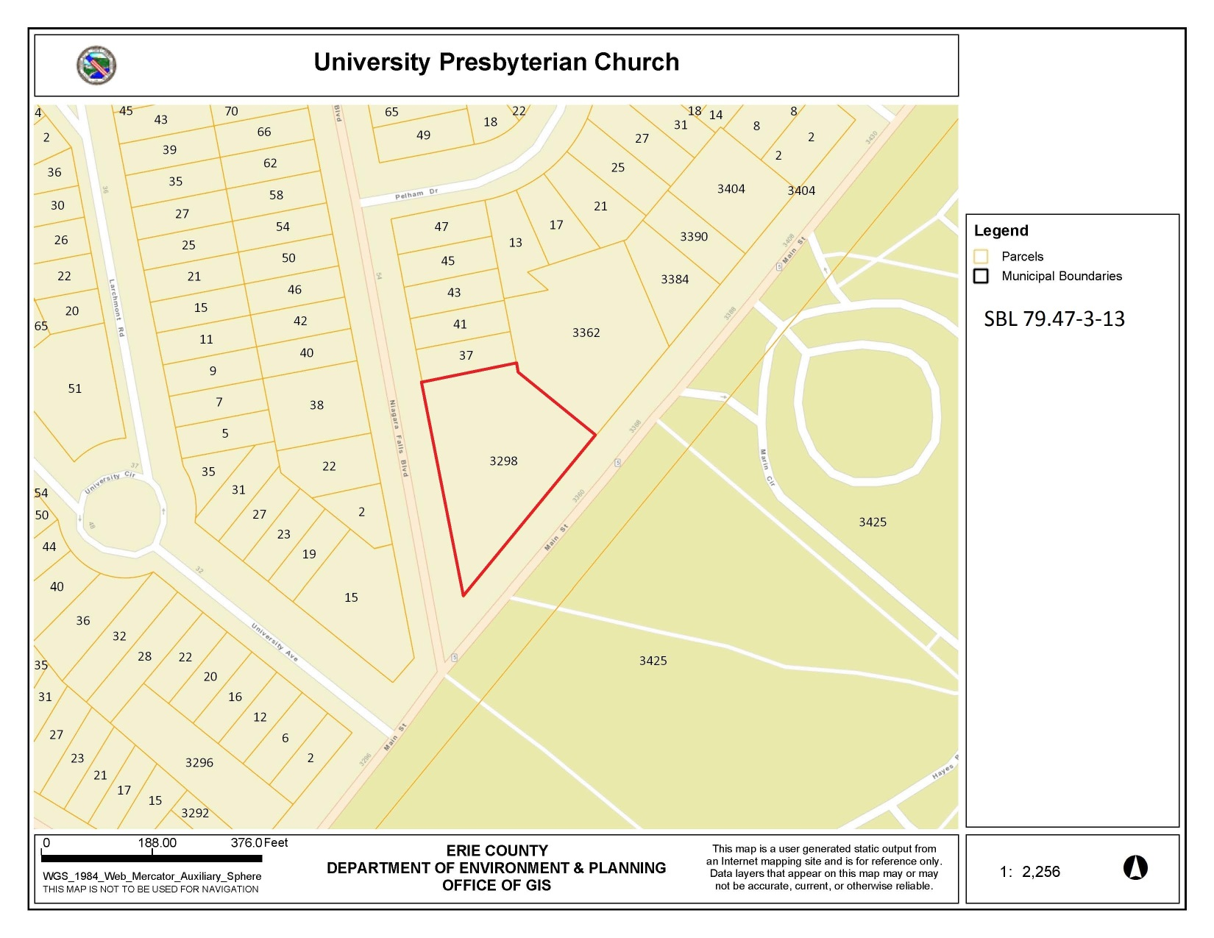

Additional Information

Photo Log:

Name of Property: University Presbyterian Church
City or Vicinity: Buffalo
County: Erie
State: New York
Name of Photographer: Kerry L. Traynor
Date of Photographs: May 2015
Location of Original Digital Files: kta preservation specialists; 422 Parker Avenue, Buffalo, NY 14216

NY_Erie County_University Presbyterian Church_ 0001
Primary west and south elevations, looking northeast, showing sanctuary and education wings, and portico and tower.

NY_Erie County_University Presbyterian Church_ 0002
Primary portico elevation and partial west sanctuary wing elevation, looking northeast.

NY_Erie County_University Presbyterian Church_ 0003
Primary portico elevation and partial south, education wing elevation, looking northeast.

NY_Erie County_University Presbyterian Church_ 0004
Primary south, education wing elevation, and east elevation looking northwest.

NY_Erie County_University Presbyterian Church_ 0005
Tertiary east elevation of education wing looking northwest.

NY_Erie County_University Presbyterian Church_ 0006
Tertiary north elevation showing education wing, sanctuary wing and elevator addition, looking southeast.

NY_Erie County_University Presbyterian Church_ 0007
Detail of tower looking northeast.

NY_Erie County_University Presbyterian Church_ 0008
Interior, narthex of sanctuary wing looking south towards main entrance.

NY_Erie County_University Presbyterian Church_ 0009
Interior, auditorium of sanctuary wing looking north from choir loft toward chancel.

NY_Erie County_University Presbyterian Church_ 0010
Interior, auditorium of sanctuary wing looking south from chancel toward choir loft.

NY_Erie County_University Presbyterian Church_ 0011
Interior, auditorium of sanctuary wing looking northwest toward chancel showing pulpit, Palladian detail at organ pipes and partial Palladian window.

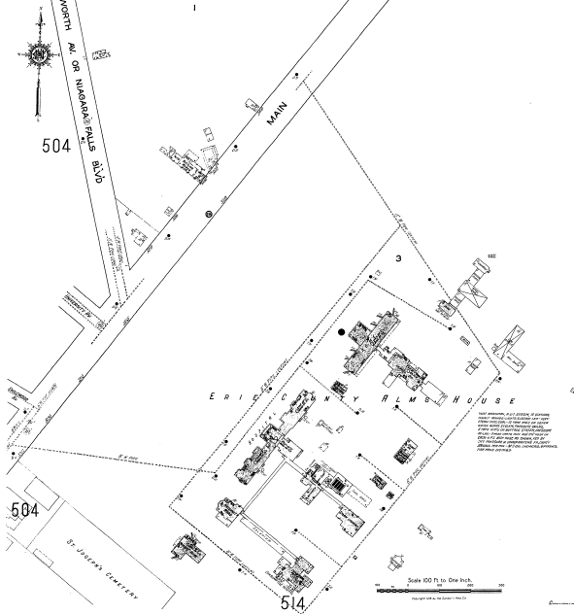

Sanborn Fire Insurance Map: Buffalo 1916-1940 vol. 5, 1916, Sheet 505.
Note vacant land around Erie County Almshouse and residence on future lot of University Presbyterian Church.

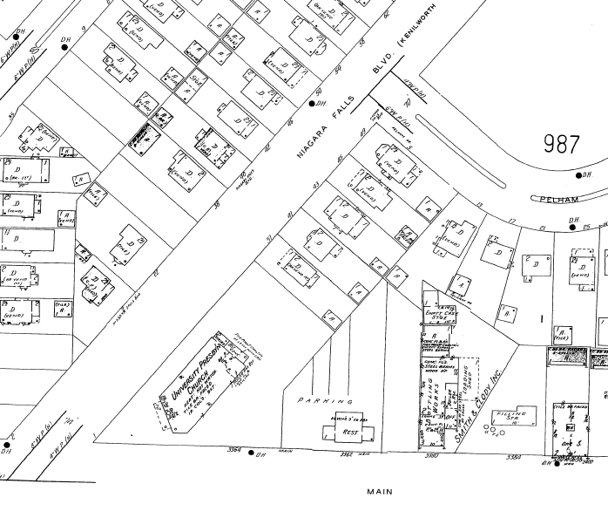

Sanborn Fire Insurance Map: Buffalo 1925-Feb. 1951 vol. 9, 1935-Nov1950, Sheet 986

Builders and Contractors involved with the Constrution of University Prebyterian Church (1927)

Contractor | Address | Service Provided
A.G. Hauenstein Lumber Co. | 3060 Main Street | Lumber
Adam Meldrum & Anderson | Main Street | Curtain Material for Organ Loft
Bame & Cuthill | 934 Ellicott Square | Lathing & Plastering
Burr Brothers | 271 Kenmore Avenue | Plumbing, heating and hardware
C. W. Beard & Son | 2699 Main Street | Decorators, painting, wood finishing
Chamberlin Metal Weather Strip Co. | 1744 Hertel Avenue | Metal weather strip
Clifford Electric Co., Inc. | 1495 Hertel Avenue | Electrical work
Decorative Illuminating Co |  | Light fixtures
Elsinghorst Bros. | 140 Broadway | Kitchen Equipment
F.G. Cook & Sons | 102 Deerhurst Park Boulevard, Kenmore | Heating
Forbes Mfg. Co |  | Church pews
Grimm & Trumpfeller | 259 Delaware Avenue | Plumbing
H.O. Crooker | 303 Jackson Building | Face brick
J.N. Adam Co | Main & Eagle Streets | Carpet & installation
Kempf’s Stone | 821 Virginia Street | Masonry
Montgomery Bros. & Co. | 254 Court Street | Mill work
Mosier & Summers | 1266 Seneca Street | Carpentry Work
Robert E. Williams & Son | 312 Jackson Street | General contractor
The Protection Fence Co. | 3151 Main Street | Construction fencing
Tobol Iron Works | Miller Avenue & N.Y.C.R.R. | Iron and steel work
United Glazing Co. | 255 Delaware Avenue | Glazing, sash
Viner and Son | 1371 – 1375 Niagara Street | Organ
Weed & Co | 95 Swan Street | Hardware
William Vossen | 1582 Delaware Avenue | Landscape Architect – grading & landscaping

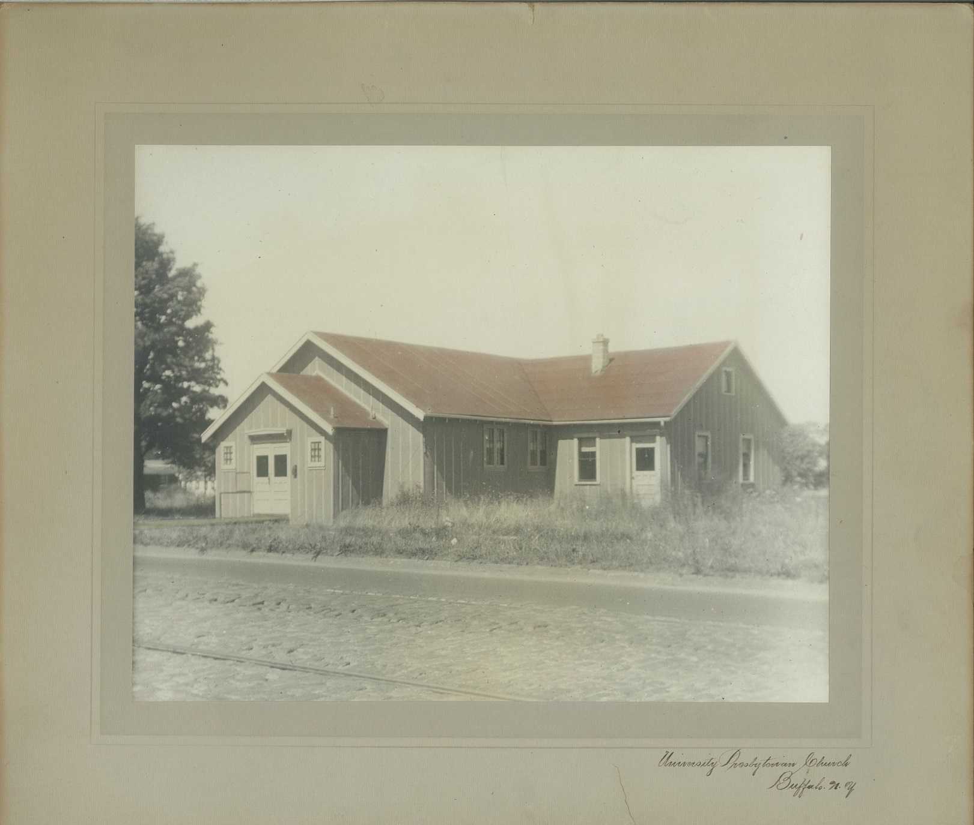
University Presbyterian Church (1921)
The original church building was moved to a site on Montrose Avenue, Town of Tonawanda for use by the Boy Scouts “Troop 6” until it was destroyed by fire on May 3, 1947. Note trolley car rails in cobble road.
Source: University Presbyterian Church archives.

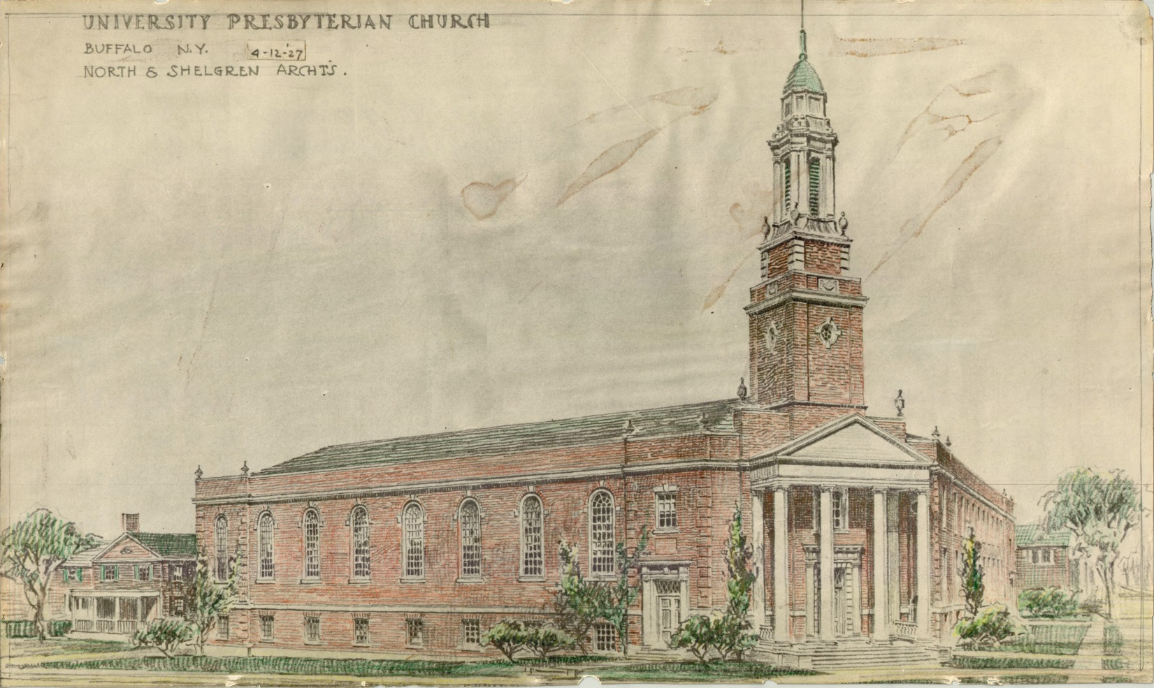
University Presbyterian Church – Architectural Rendering (April 12, 1917)
The rendering shows the two phases of construction: The Sancturary Wing and the Education Wing. The 1955 design for the Education Wing realized the original design intent.
Source: University Presbyterian Church Archives.

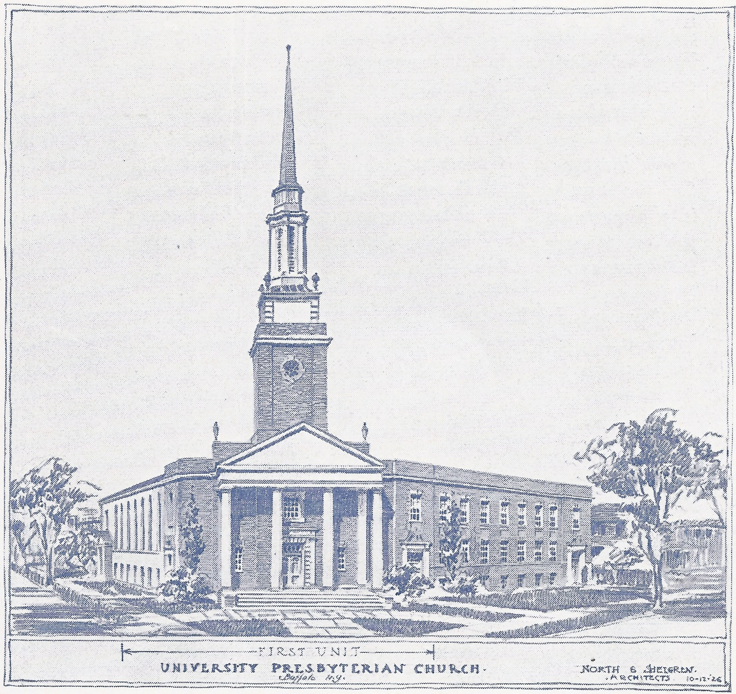

Universty Presbyterian Church – Rendering North & Shelgren, architects. (October 12, 1926)
Source: University Presbyterian Church. Plans of the University Presbyterian Church. (Buffalo: The Grotzka Press, 1926), n.p.

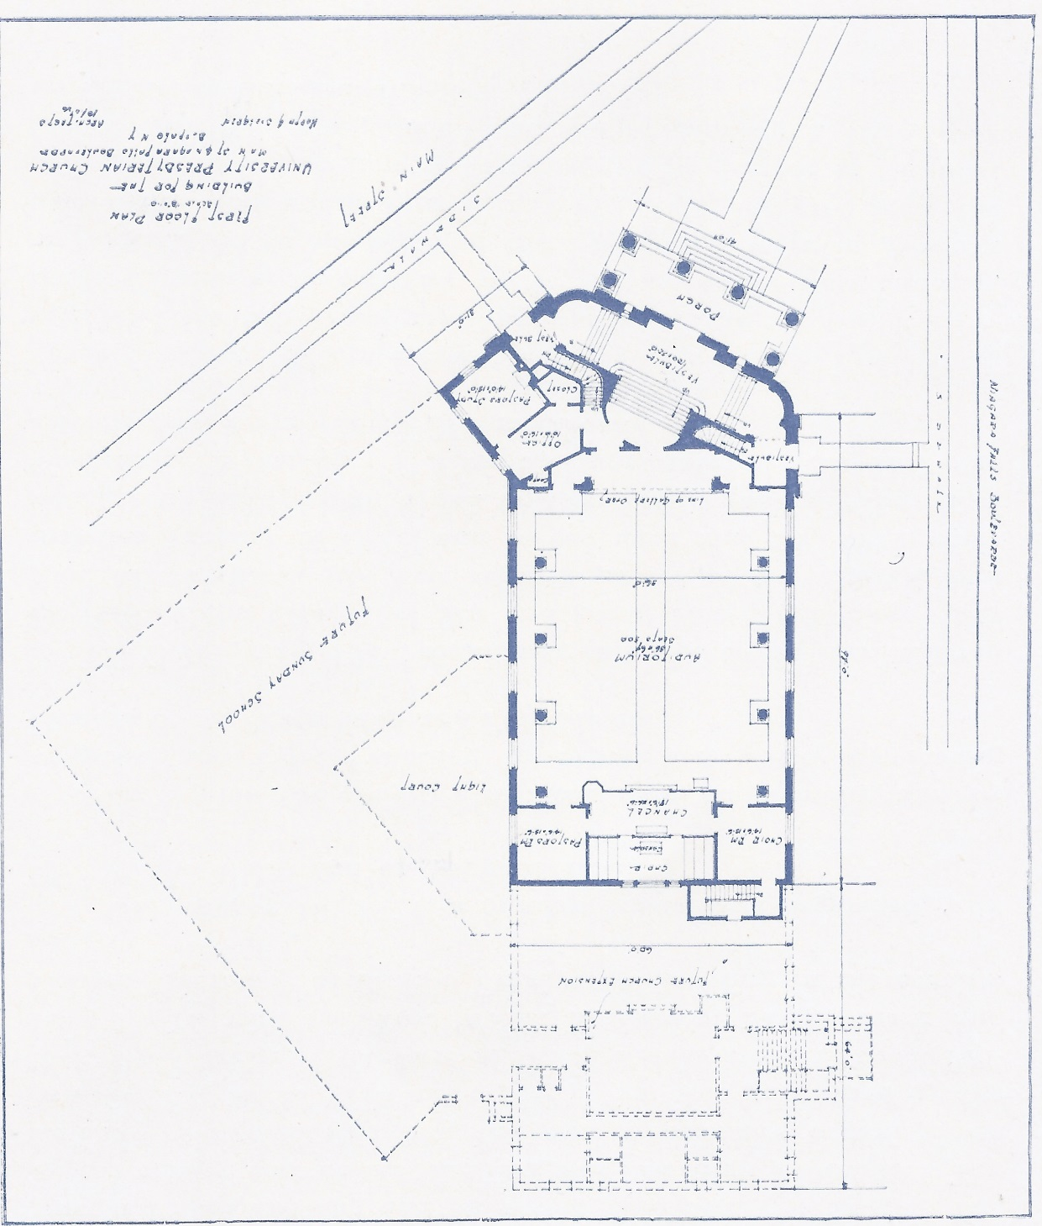
First Floor Plan of Sanctuary, University Presbyterian Church,
North &Shelgren, architect. (October 6, 1926)
Note that North & Shelgren plan includes the furture Sunday School addition.
Source: University Presbyterian Church. Plans of the University Presbyterian Church. (Buffalo: The Grotzka Press, 1926), n.p.
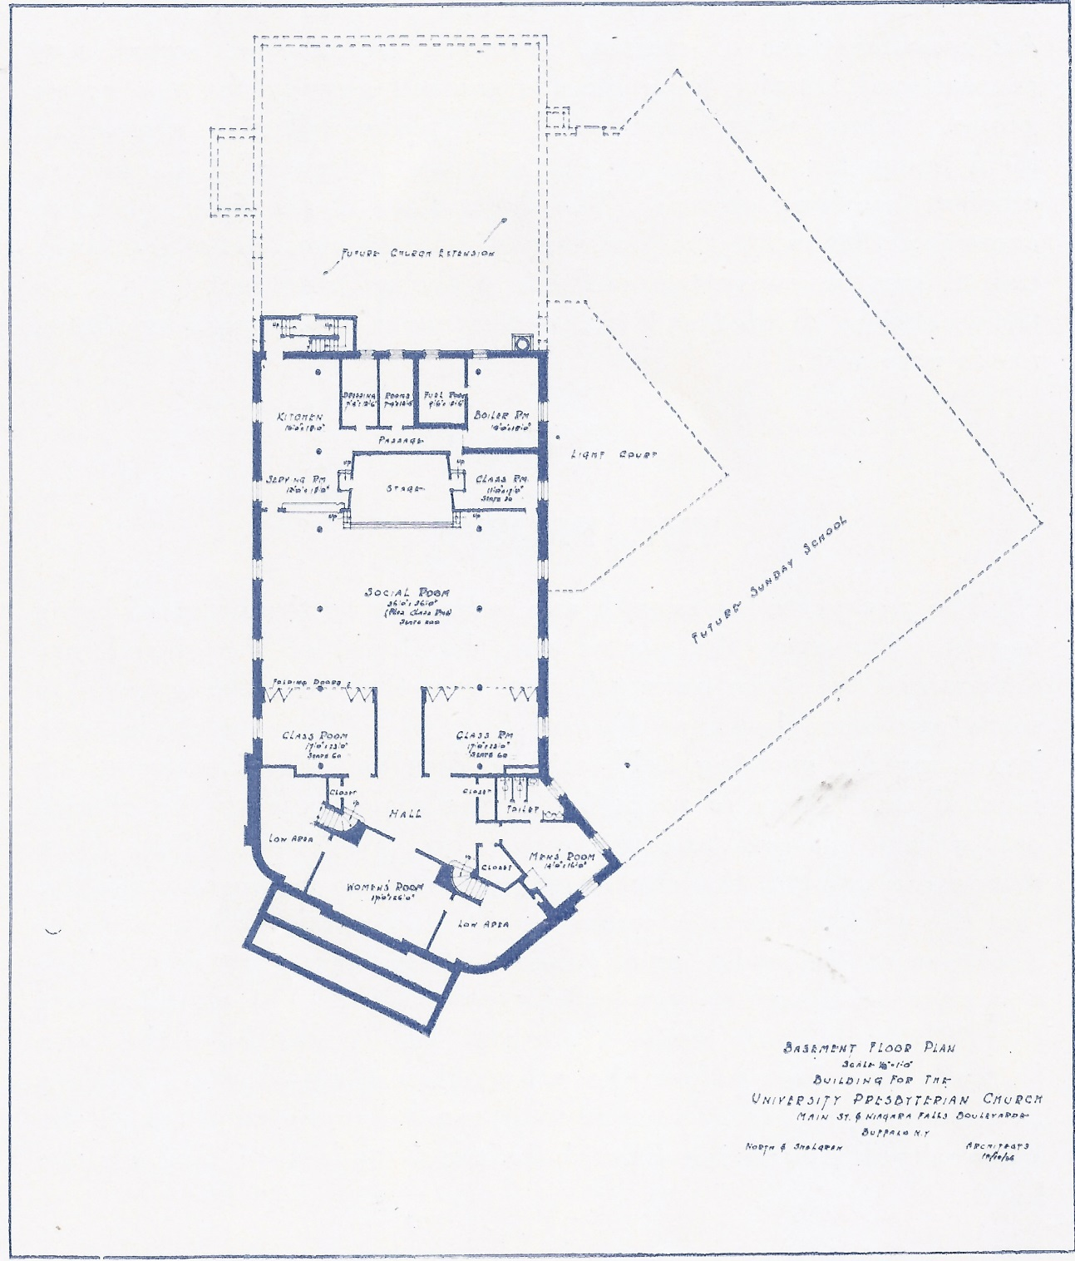

Basement Plan of Sanctuary, University Presbyterian Church,
North &Shelgren, architect. (October 6, 1926)
Note that North & Shelgren plan includes the furture Sunday School addition.
Source: University Presbyterian Church. Plans of the University Presbyterian Church. (Buffalo: The Grotzka Press, 1926), n.p.

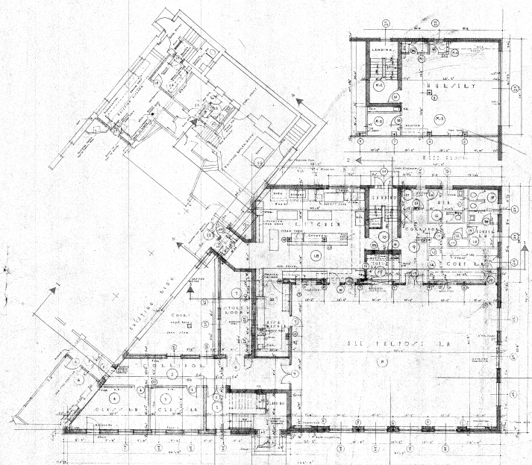

Ground Floor Plan, Church School Addition, Fenno – Renolds – McNeil, architects (June 10, 1955)
The education wing addition realized the original 1926 design vision.

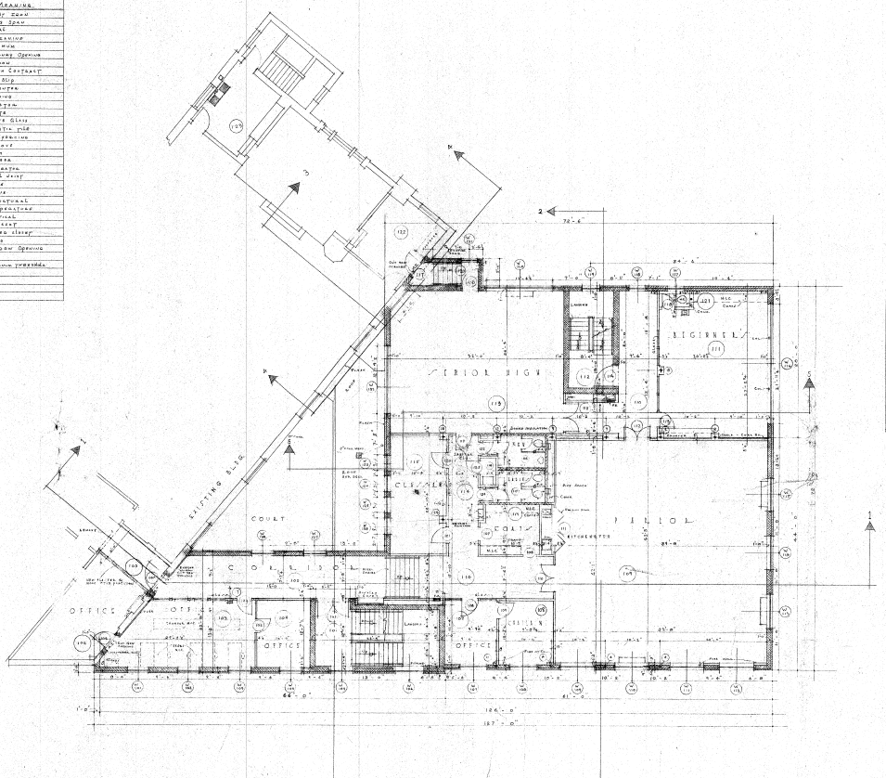

First Floor Plan, Church School Addition, Fenno – Renolds – McNeil, architects (June 10, 1955).
The education wing addition realized the original 1926 design vision.
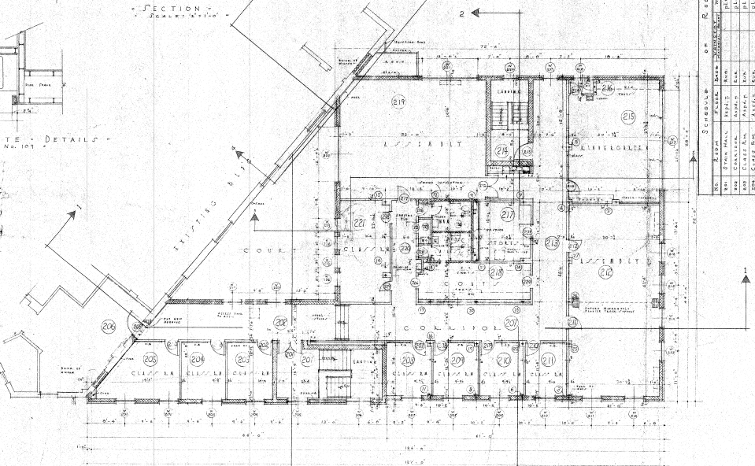

Second Floor Plan, Church School Addition, Fenno – Renolds – McNeil, architects (June 10, 1955).
The education wing addition realized the original 1926 design vision.

For the sake of clarity Main Street will be assumed to run in an east-west direction. The 1926 and 1955 construction drawings made similar assumptions regarding Main Street in noting the orientation of the building elevations.
University Presbyterian Church, “December, 1948 … 37 Niagara Falls Boulevard Acquired,” Fifty Years of Preparation 1921-1971. Pamphlet on File, University Presbyterian Church Archives. N.p. In December 1948 University Presbyterian Church purchased the property at 37 Niagara Falls Boulevard. The building is a contributing property in the University Park Historic District. The property (SBL 79.47-3-14) is separate from the University Presbyterian Church property.
R. Randal Phillips, “Church Towers, Steeples, and Spires of Sir Christopher Wren, “The Brickbuilder (New York: Rogers and Manson Company, 1915), 186.
The lower ceiling heights in the education wing allow for the accommodation of an additional floor level at the northeast corner.
The original Roosevelt organ was replaced on September 11, 2001.
The fireplaces were originally intended to be wood burning. However fire code requirements would have resulted in the construction of chimneys that increased the budget. Dummy fireplaces with radiant heaters were constructed to save costs.
Blumcraft aluminum products including panic hardware, railing systems and display case doors remain on the market.
The University Presbyterian Church, Opening of the New Church, Souvenir Program, (Buffalo:, 1927), 21.
The University Presbyterian Church, The University Presbyterian Church (Buffalo: Grotzka Press, 1927), 3.
In 1824 New York State passed a law requiring that counties build almshouses for the indigent. The first building in Erie County was constructed in 1828 at Fargo and Porter Avenues. In 1851 the county purchased 148 acres just north of the city lines and constructed a series of buildings including residences for men and women, a hospital, a tuberculosis ward and a large asylum for the mentally ill.
Anthony J. Huck, University Park: A Restricted Residence Subdivision (Buffalo,1914), 3.
National Register Multiple Property Documentation Form, “Multiple Resources Associated with the Suburban Development of Buffalo, NY.
In the foreground of a period photo of the church the trolley car rails are clearly visible.
The University Presbyterian Church, Opening of the New Church, Souvenir Program (Buffalo, 1927), 8.
Board of Trustees, Board of Trustees & Session Minutes, March 27, 1921, University Presbyterian Church Archives.
University Presbyterian Church, Opening of the New Church, Souvenir Program, Buffalo, 1927, 9. The original church building was moved to a site on Montrose Avenue, Town of Tonawanda for use by the Boy Scouts “Troop 6” until it was destroyed by fire on May 3, 1947.
University Presbyterian Church, The University Presbyterian Church, (Buffalo: Grotzka Press, 1927), 3.
Ibid.
University Presbyterian Church, “$25,000 Building Campaign,” The U-P-C Bulletin, 1926.
Woman’s Association, Minutes, Documents on file, University Presbyterian Church Archives, 1922 – 1935. In addition to raising funds for the building campaign, the Woman’s Association made clothes for the Charity Society (Minutes, February 1926); made and sent nightgowns to a hospital in Korea (Minutes, May 1928) and raised money for, and sent clothes to the Friendship House in Lackawanna, NY (Minutes, September 1931; March 1932; November 1932)
University Presbyterian Church, Opening of the New Church, Souvenir Program, Buffalo, 1927, 16. The builders advertised themselves as the general contractors for the building of the church in the Souvenir Program.
A rendering by North & Shelgren dated 10-12-26 focuses on the Education Wing elevation along Main Street, whereas a later rendering, dated 4-12-27, focuses on the Sanctuary Wing elevation along Niagara Falls Boulevard.
In 1926 North was also renovating Lafayette Presbyterian Church in Buffalo (NR listed 8/21/2009). North proposed a decorative scheme and reorganization of the chancel area that was simplified. His design for the auditorium used authentic classical motifs including Corinthian columns and unfluted Ionic columns
Board of Trustees, Board of Trustees & Session Minutes, October 12, 1927, University Presbyterian Church Archives.
North & Shelgren, “First Floor Plan,” Building for University Presbyterian Church, Construction Drawings, Buffalo: North & Shelgren, 1927. The University Presbyterian Church, The University Presbyterian Church (Buffalo: Grotzka Press, 1927), 4-5. The construction document for the First Floor Plan notes that the auditorium seats 420 people. The Basement Plan does not note the capacity in the assembly hall. The fundraising document published in 1927 notes that “the auditorium will seat 500, with 150 in addition in the gallery” and that assembly hall would seat 200 people, which would increase to a capacity of 300 people when the rooms separated by folding doors were included.
“Special Meeting of the Building Committee,” Minutes Board of Trustees University Presbyterian Church. On February 14, 1927 the church made arrangements with Viner Organ Co. to purchase a Roosevelt organ formerly used at the First Presbyterian Church.
Prior to 1945 the Presbytery helped the church cover operating expenses. As a result of this financial dependence University Presbyterian Church was considered a mission church. In 1945 the church prepared a budget with no anticipated help from the Presbytery and was no longer considered a mission church.
“$150,000 Is Sought for Church Wing,” Buffalo Courier Express, June 6, 1954
“University Church Making Progress on New Building.” Tonawanda News, October 1, 1955.
University Presbyterian Church, “September 16, 1956 New Building Dedicated,” Fifty Years of Preparation 1921-1971. Pamphlet on File, University Presbyterian Church Archives. N.p.
Ibid.
“Miami Call Accepted By Rev. Mr. Kuhen,” Buffalo Courier Express, July 31, 1965. Reverend Kuhen was installed as pastor of University Presbyterian Church on September 30, 1959, succeeding the Reverend Leslie Reid. The article describes University Presbyterian Church as one of the largest Presbyterian churches in Western New York.
The Child and Adolescent Psychiatric Clinic is now referred to as Child and Adolescent Treatment Services.
Franklin Buell. “University Church Gets Rezoning for Psychiatric Clinic,” Buffalo Evening News, August 3, 1978.
“University Presbyterian Church Virtually Ready,” Buffalo Courier Express, February 3, 1928.
“Ground Breaking: Ceremony for New Boulevard Church Tomorrow,” Buffalo Times, Nov 13, 1926.
University Presbyterian Church, Fifty Years of Preparation 1921-1971. Pamphlet on File, University Presbyterian Church Archives. A copy of the “Bulletin for the Month of September, 1922” is reproduced in the pamphlet.
A Brief Chronological History of the First Fifty Years of the University Presbyterian Church.
Ministry with students at the University at Buffalo continues with students participating in worship and weekly luncheons and discussion following church services during the academic year. The Manse is leased out to university students with intentional Christian living.
Board of Trustees, Board of Trustees & Session Minutes, 1928, University Presbyterian Church Archives.
Refer to footnote 20 above.
H. Katherine Smith. “Men You Ought To Know,” Buffalo Courier Express, July 22, 1928.
“Robert North, Architect, Dies at 85,” Buffalo Evening News, May 3, 1968.
Lee F. Heacock, ed., Buffalo Artists’ Register, vol I (Buffalo, N.Y.: Heacock Publishing Corporation, 1926), 435; “Olaf W. Shelgren Dies, Noted Church Architect,” Buffalo Evening News, August 17, 1972.
“S. Harold Fenno Services Are Held,” North Tonawanda Evening News, August 25, 1986.
American Architects Directory, accessed online, June 30, 2015: http://public.aia.org/sites/hdoaa/wiki/American%20Architects%20Directories/1962%20American%20Architects%20Directory/Bowker_1962_R.pdf
“Daniel McNeil, Local Architect Dies in Buffalo,” North Tonawanda Evening News, October 6, 1958.
Minutes Board of Trustees University Presbyterian Church April 7, 1926 – February 29th, 1928. The Trustee meetings documented solicitation of bids for the work. The lowest, qualified bid was selected. The Building Committee reported at the Trustee Meetings, however they also met separately. The Buildings Committee meeting minutes are not held in the church’s archives.

